

MADDA WALABU UNIVERSITY
Yuunivarsiitii Maddaa Walaabuu
"Devoted to Impact"
COLLEGE OF AGRICULTURE AND NATURAL RESOURCES
DEPARTMENT OF ECOTOURISM AND BIODIVERSITY CONSERVATION
PRACTICAL ATTACHMENT REPORT
ON
SEEDLING PRODUCTION AND NURSERY MANAGEMENT, MEDICINAL, INDIGENOUS AND ENDEMIC PLANT CONSERVATION, PLANT TAXONOMY, HERBARIUM PREPARATION, COMPOST PRODUCTION AND ECOTOURISM SERVICES
Conducted at
ETHIOPIAN BIODIVERSITY INSTITUTE (EBI)
SHASHEMENE BOTANICAL GARDEN (SBG)
Shashemene, West Arsi Zone, Oromia Regional State, Ethiopia
Prepared by | DERARTU TAYE
ID No. | [STUDENT ID NUMBER]
Academic Advisor | [NAME AND TITLE OF ADVISOR]
Academic Year | [2018 E.C. / 2025–2026 G.C.]
Robe, Bale, Ethiopia
[July- August, 2026]
Submitted in partial fulfilment of the requirements of the Practical Attachment Programme

DECLARATION AND APPROVAL
I, the undersigned, declare that this practical attachment report, entitled "Practical Attachment Report on Seedling Production and Nursery Management, Medicinal, Indigenous and Endemic Plant Conservation, Plant Taxonomy, Herbarium Preparation, Compost Production and Ecotourism Services, conducted at the Ethiopian Biodiversity Institute, Shashemene Botanical Garden", is my own original work. It was prepared on the basis of the tasks I personally carried out, the observations I recorded in the field, the measurements and specimens I collected, and the guidance I received from the professional staff of the host institution during the attachment period.
All sources of information used or quoted in this report have been duly acknowledged in the reference section. This report has not been submitted, in whole or in part, for the award of any degree or diploma in this or any other university.
Name of student | Signature | Date
Derartu Taye

This practical attachment report has been submitted for examination with my approval as the academic advisor of the student, and with the confirmation of the host institution supervisor.
Role | Name | Signature | Date
Academic Advisor
Host Supervisor (EBI/SBG)
Department Head
External Examiner

ACKNOWLEDGEMENT
First and foremost, I thank the Almighty God for the health, patience and opportunity to complete this practical attachment successfully.
I sincerely thank Madda Walabu University and the Department of Ecotourism and Biodiversity Conservation for arranging the attachment. I am also grateful to Abid Gemechu at Madda Walabu University for the academic guidance and support he gave throughout the preparation of this report.
I am deeply grateful to the Ethiopian Biodiversity Institute and to Shashemene Botanical Garden for accepting me as a trainee. My particular thanks go to Kedir Erbo, Director of Shashemene Botanical Garden, for approving my placement and giving me full access to the nursery, the conservation blocks, the mini herbarium and the outreach sites, and to Jemal Woticha, my supervisor and mentor at the garden, whose daily guidance and patience shaped almost everything I learned during this attachment. The wider team of researchers and field technicians also shared their professional experience generously and treated me as a member of the working team rather than as a visitor.
I would also like to thank Lencho Taye, a student at Adama Science and Technology University, for the technical support he gave throughout this project, including his work on the digital documentation platform that accompanies this report.
Finally, I thank my family for their moral and material support, and my classmates and friends who helped with data organisation and photographic documentation.

EXECUTIVE SUMMARY
Conclusion and recommendations. The practical attachment at the Ethiopian Biodiversity Institute (EBI), Shashemene Botanical Garden (SBG), met its purpose. The trainee worked inside an operating national conservation institution and carried out real tasks in eight working areas. Nine of the ten objectives were achieved (one with an open species record) and one, field identification of unlabelled sterile plants, was partially achieved. The main lesson is that conservation is a documentation discipline before it is a planting discipline: a seedling with no accession record, a specimen with no label and an attraction with no interpretation are all incomplete.
The principal recommendations to the host are to complete and digitise the accession records of the conservation blocks; to invest in interpretive panels in Afaan Oromo, Amharic and English at the Qiltu heritage tree, the endemic block and the Melka Oda river corridor before any new infrastructure; and to formalise trainee intake. Madda Walabu University is advised to increase field hours in plant taxonomy and herbarium technique and to assess field record keeping and interpretation design as skills in their own right.
The attachment. SBG lies in Shashemene, West Arsi Zone, Oromia, about 245 km south of Addis Ababa. It covers about 17.07 ha at 1,950 to 1,980 masl and is one of the botanical gardens under EBI, the national institution mandated to conserve the biological diversity of Ethiopia. The working areas were nursery management and seedling production; the medicinal, indigenous and endemic plant gardens; plant taxonomy and field identification; herbarium preparation; compost production; and, because the trainee is an ecotourism student, the visitor services and community outreach functions of the garden.
Outputs. The trainee took part in bed preparation, media mixing, sowing and pricking out; recorded medicinal, indigenous and endemic species with scientific, Amharic and Afaan Oromo names; prepared and labelled herbarium specimens; built and turned a compost heap; assessed the interpretation status of the main attraction sites; and published a digital portfolio at ebi-intern.pages.dev holding the full photographic and field record.
Key words: practical attachment, Ethiopian Biodiversity Institute, Shashemene Botanical Garden, ex situ conservation, seedling production, medicinal plants, endemic species, plant taxonomy, herbarium, composting, ecotourism.

TABLE OF CONTENTS
1. INTRODUCTION 1
1.1 Background of the Practical Attachment Programme 1
1.2 History of the Host Organisation 1
1.3 Profile of Shashemene Botanical Garden 2
1.4 Experience and Capacity of the Host Organisation 4
1.5 Overview of the Attachment Programme Undertaken 5
2. OBJECTIVES OF THE PRACTICAL ATTACHMENT 6
2.1 General Objective 6
2.2 Specific Objectives 6
2.3 Learning Objectives 7
2.4 Relationship of the Attachment to Classroom Courses 7
3. MATERIALS AND METHODS 8
3.1 Approach 8
3.2 Materials, Tools and Equipment Used 8
3.3 Method of Data Recording 8
3.4 Limitations of the Method 9
4. MAIN BODY: ACTIVITIES PERFORMED 10
4.1 Nursery Management and Seedling Production 10
4.2 The Medicinal Plant Garden 13
4.3 The Indigenous Plant Garden 14
4.4 The Endemic Plant Garden 15
4.5 Plant Taxonomy and Field Identification 16
4.6 Herbarium Specimen Preparation 17
4.7 Compost Production 19
4.8 Ecotourism, Environmental Education and Community Service 21
4.9 Digital Documentation Portfolio 22
4.10 Weekly Activity Log 24
4.11 Skills and Competences Acquired 25
5. REVIEW OF OBJECTIVES AGAINST ACHIEVEMENT 26
5.1 Achievement of the Specific Objectives 26
5.2 Review of the Learning Objectives 26
5.3 Comparison of Classroom Learning and Real Site Work 27
5.4 The Gap Between Real Work and Class Learning 27
6. CHALLENGES ENCOUNTERED 29
7. CONCLUSION 30
8. RECOMMENDATIONS 31
8.1 To the Host Institution: Ethiopian Biodiversity Institute and SBG 31
8.2 To Madda Walabu University and the Department 31
8.3 To Future Trainees 32
REFERENCES 33
APPENDICES A-1
Appendix I. Daily Activity Record A-1
Appendix II. Plant Species Record Sheet A-2
Appendix III. Herbarium Specimen Label Template A-3
Appendix IV. Photographic Documentation A-4
Appendix V. Digital Documentation Portfolio A-4

LIST OF TABLES
Table 1 Institutional profile of Shashemene Botanical Garden 2
Table 2 Conservation blocks and outreach sites of SBG 4
Table 3 Working areas covered during the practical attachment 5
Table 4 Materials, tools and equipment used during the attachment 8
Table 5 Major operations in nursery and seedling production 11
Table 6 Potting media composition used at the SBG nursery 11
Table 7 Selected medicinal and economically significant species recorded at SBG 13
Table 8 Indigenous plant species recorded in the indigenous block 14
Table 9 Endemic and nationally significant species recorded in the endemic block 15
Table 10 Taxonomic classification of selected species recorded at SBG 16
Table 11 Vegetative and reproductive characters used for field identification 17
Table 12 Standard information recorded on a herbarium label 18
Table 13 Materials used and layering sequence for compost preparation 20
Table 14 Attraction sites of SBG and their ecotourism interpretation status 21
Table 15 Structure and content of the digital documentation portfolio 23
Table 16 Weekly activity log of the practical attachment 24
Table 17 Skills and competences acquired during the attachment 25
Table 18 Review of objectives against achievement 26
Table 19 Comparison of classroom learning and real site work 27
Table 20 Challenges encountered and measures taken 29

LIST OF FIGURES
Figure 1 Organisational position of SBG within the Ethiopian Biodiversity Institute 2
Figure 2 Main gate and general view of Shashemene Botanical Garden 3
Figure 3 Layout sketch of the conservation blocks of the garden 4
Figure 4 The SBG nursery site and shade structures 10
Figure 5 Preparation of potting media and filling of polythene tubes 12
Figure 6 Sowing, pricking out and watering of seedlings 12
Figure 7 Hardening off and seedlings ready for transplanting 12
Figure 8 The medicinal plant garden 13
Figure 9 A recorded medicinal species 13
Figure 10 The indigenous plant block 15
Figure 11 The endemic plant block 16
Figure 12 Field identification practice using vegetative characters 17
Figure 13 Collection of plant specimens in the field 19
Figure 14 Pressing and drying of specimens 19
Figure 15 Mounted and labelled herbarium sheets 19
Figure 16 Collection and layering of compost materials 20
Figure 17 Turning of the heap and the matured compost 20
Figure 18 The Qiltu heritage site 22
Figure 19 The Melka Oda river crossing the garden 22
Figure 20 Environmental education and community service activities 22
Figure 21 Home page of the digital documentation portfolio 23
Figure 22 Trainee at work with SBG staff 25

LIST OF ACRONYMS AND ABBREVIATIONS
Abbr. | Meaning | Abbr. | Meaning
Af. Oromo | Afaan Oromo | HLST | Horticulture and Landscaping Team
Amh. | Amharic | IBC | Institute of Biodiversity Conservation
CBD | Convention on Biological Diversity | IBCR | Institute of Biodiversity Conservation and Research
E.C. | Ethiopian Calendar | masl | Metres above sea level
EBI | Ethiopian Biodiversity Institute | MWU | Madda Walabu University
ECCT | Exploration, Collection and Conservation Team | PDMT | Planning and Data Management Team
ECST | Education and Community Service Team | PGRC/E | Plant Genetic Resources Centre, Ethiopia
G.C. | Gregorian Calendar | SBG | Shashemene Botanical Garden
GPS | Global Positioning System | spp. | Species (plural)
ha | Hectare | subsp. | Subspecies

1. INTRODUCTION

1.1 Background of the Practical Attachment Programme
Higher education in the natural resource disciplines cannot be completed inside a lecture hall. Courses such as plant taxonomy, conservation biology, protected area management and sustainable tourism development supply the concepts and the vocabulary, but they cannot supply the judgement that comes from handling a living collection, from failing to identify a specimen in the field, or from watching how an institution converts a conservation mandate into a daily work plan. Practical attachment exists to close that distance.
For this reason the Department of Ecotourism and Biodiversity Conservation of Madda Walabu University (MWU) requires every student to spend a defined period attached to a recognised organisation working in the field. During this period the student is expected to function as a junior member of the host organisation, to participate in its routine operations, to record what is observed in a systematic manner, and to report both what was learned and where the gaps lie.
This attachment was conducted at the Ethiopian Biodiversity Institute (EBI), Shashemene Botanical Garden (SBG). The choice of host was deliberate. A botanical garden is one of the very few institutions where the two halves of the degree programme meet in one compound: it is a conservation facility holding living collections, a nursery, a herbarium and field gene banks, and it is also a visitor attraction receiving school groups, urban residents and cultural gatherings. The conservation science and the visitor management functions therefore operate on the same landscape, under the same management, and often in tension with each other. That tension is the central professional problem of the discipline.

1.2 History of the Host Organisation
The Ethiopian Biodiversity Institute is the national institution mandated to conserve the biological diversity of Ethiopia. Its origins go back to May 1976, when the Plant Genetic Resources Centre, Ethiopia (PGRC/E) was established through a bilateral technical cooperation agreement between the Government of Ethiopia and the Government of Germany. The main objective at that time was to rescue the plant genetic resources of the country from the combined pressure of expanding modern varieties, habitat loss, drought and famine, and to place that diversity at the service of crop improvement programmes.
The mandate has widened several times since then. In 1998 the centre was re-established as the Institute of Biodiversity Conservation and Research (IBCR), so that Ethiopia could implement its obligations under the Convention on Biological Diversity (CBD). In 2004 the establishing legislation was amended and the organisation became the Institute of Biodiversity Conservation (IBC). In 2013 it took its present structure and its present name, the Ethiopian Biodiversity Institute.
The institute today works through research directorates covering animal biodiversity, crop and horticulture biodiversity, forest and rangeland plant biodiversity, microbial biodiversity, and genetic resources access and benefit sharing, together with a directorate for training, consultancy and project support. Its field structure includes regional biodiversity centres, botanical gardens and gene bank facilities, and its genebank has long been recognised as one of the most significant in Africa. Shashemene Botanical Garden operates within this structure, so every activity observed in the garden, from the sowing of a seed to the mounting of a herbarium sheet, is ultimately an instrument of a national conservation mandate and of an international convention.
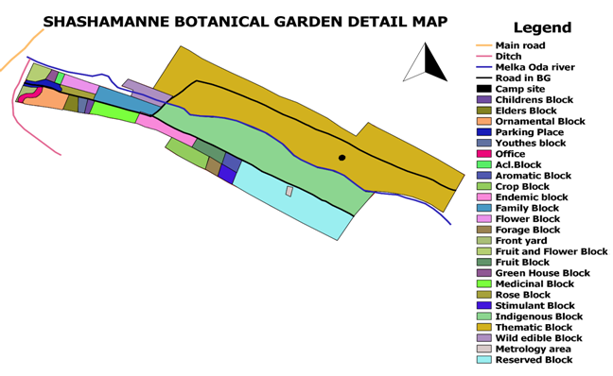
Figure 1. Organisational position of SBG within the Ethiopian Biodiversity Institute

1.3 Profile of Shashemene Botanical Garden
Shashemene Botanical Garden is located in Shashemene town, West Arsi Zone of Oromia Regional State, about 245 km south of Addis Ababa. Its geographic position is approximately 7°12′48″ N and 38°37′14″ E, its altitude ranges between 1,950 and 1,980 metres above sea level (masl), and it covers about 17.07 hectares (ha).
The garden was established in 2005 on the basis of an agreement between the Shashemene city administration and EBI. Before that transfer the site had been a forest tree seedling planting site managed by the city council. Although the agreement dates from 2005, the garden began full operation in 2015, after staff were recruited and office facilities were constructed. This gap is instructive, because it shows that a conservation site requires institutional capacity, not only a land allocation, before it can function.
The topography is moderately sloping and the soil is sandy loam; parts of the compound were formerly highly eroded and shallow and are now rehabilitating. Melka Oda, the only permanent river in the area, crosses the garden and flows westward. It is the most important natural resource of the site, supplying water for the nursery and for young seedlings planted out in the field. Vernonia galamensis is the symbolic plant of the garden.
Table 1. Institutional profile of Shashemene Botanical Garden
Attribute | Description
Parent institution | Ethiopian Biodiversity Institute (EBI)
Location | Shashemene town, West Arsi Zone, Oromia Regional State
Distance from Addis Ababa | About 245 km to the south
Geographic coordinates | Approximately 7°12′48″ N, 38°37′14″ E
Altitude | 1,950 to 1,980 metres above sea level
Total area | About 17.07 hectares
Year of establishment | 2005 (agreement); full operation from 2015
Topography and soil | Moderately sloping; sandy loam, partly rehabilitated from erosion
Water source | Melka Oda River, the only permanent river in the area
Staff complement | About 40 employees, of whom 7 are researchers (4 MSc, 3 BSc)
Research teams | ECCT, ECST, HLST and PDMT (proposed team structure)
Mini herbarium | More than 250 dried specimen collections

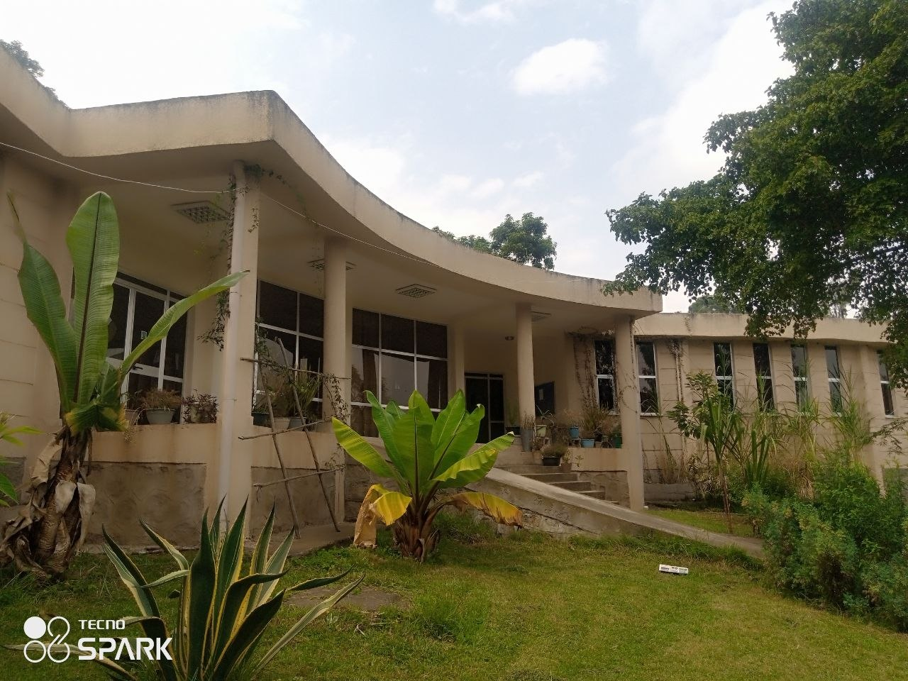
Figure 2. Main gate and general view of Shashemene Botanical Garden

1.3.1 Vision, mission and objectives of the garden
The vision of the garden is to become an internationally recognised nature-based and cultural visitor attraction contributing to the aspiration of Ethiopians for an outstanding quality of life. Its mission is to maintain, display and interpret plant collections to the highest standards, in a manner that is purpose driven, prioritised and systematically documented, and that contributes to conservation, education, aesthetics and research on biodiversity for sustainable development.
Four objectives follow: to conserve and enhance the botanical collections in recognition of their national importance and their linkage to the national biodiversity strategy; to provide education and raise public awareness; to conduct research on plant biodiversity, its uses and its management; and to promote tourism by facilitating the garden for visitors. Two of the four objectives are therefore education and visitor promotion, which places ecotourism at the centre of the mandate of the garden rather than at its margin.

1.3.2 Conservation structure and outreach sites
Conservation of plants is the principal objective of the garden. Three priorities guide the selection of material: economically important crops and plants, endemic and rare species, and indigenous species. Planting material is collected from different parts of the country by the exploration, collection and conservation team, in the form of seeds, wild seedlings, cuttings or rhizomes.
Ex situ conservation is organised into eleven plant blocks holding more than 350 species in total. Conservation is also carried out outside the compound, at the Wondo Genet medicinal field gene bank (more than 320 medicinal species), the Lepis forest field gene bank (more than 67 tree and shrub species) and the Gara Iffa species restoration site. The garden also manages two outreach sites: Gara Iffa, a species restoration site of about 38.25 ha established in 2021, and Aje, an area closure and reforestation site of about 16 ha established in 2018.
Table 2. Conservation blocks and outreach sites of SBG
Category | Component | Remark
Ex situ blocks (11) | Fruit block; Flower garden; Medicinal plant garden; Family block | More than 350 species conserved in total
 | Endemic plants garden; Indigenous plants garden; Aromatic plants garden | Core blocks visited during this attachment
 | Stimulant plants garden; Rose garden; Wild edible plants; Economic plants garden | Support education and visitor interest
Field gene banks | Wondo Genet medicinal field gene bank | More than 320 medicinal species
 | Lepis forest field gene bank | More than 67 tree and shrub species
Outreach sites | Gara Iffa species restoration site (2021) | About 38.25 ha
 | Aje area closure and reforestation site (2018) | About 16 ha

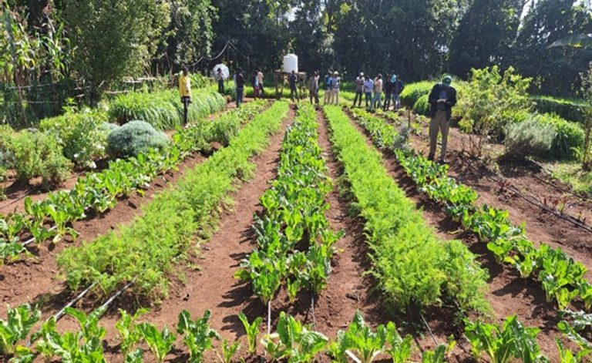
Figure 3. Layout sketch of the conservation blocks of the garden

1.4 Experience and Capacity of the Host Organisation
The capacity of the garden rests on three foundations. The first is professional staffing. Of about forty employees, seven are researchers in the technical department, four holding MSc degrees and three holding BSc degrees, supported by about thirty-three staff in administrative and field support roles. The research function is organised into four teams covering exploration, collection and conservation (ECCT), education and community service (ECST), horticulture and landscaping (HLST), and planning and data management (PDMT).
The second is technical infrastructure: a nursery supplied by the Melka Oda river, eleven conservation blocks, and a mini herbarium of more than 250 dried specimens staffed by experienced botanists who provide plant identification services to researchers.
The third is a service portfolio that extends beyond conservation. The garden provides herbarium and identification services; training for field workers, community members and practitioners in biodiversity conservation and management, herbarium technique, nursery management, seed collection and invasive plant management; advisory services on conservation and invasive species control; and seedlings on demand for conservation purposes. It also hosts cultural events such as Abagada and Hara Sinke ceremonies, exhibitions and festivals, camping, and private celebrations. This mix is exactly the profile of a working ecotourism site, and it made the garden a suitable host for a student of this department.
Why this host matters for an ecotourism and biodiversity conservation student
A botanical garden is a conservation institution and a visitor destination at the same time. Every decision taken at SBG has to satisfy two masters: the integrity of the living collection and the experience of the visiting public.
This attachment therefore examined not only how plants are propagated and documented, but also how a conservation site manages access, interpretation, cultural use and community relations without compromising the collection.

1.5 Overview of the Attachment Programme Undertaken
The attachment was carried out in the main compound of the garden, with supporting visits to the nursery, the conservation blocks, the mini herbarium, the compost site and the principal attraction points. Work was organised around eight working areas, each supervised by the relevant staff member. The trainee participated directly in routine operations rather than observing them from a distance, and kept a daily field notebook that forms the basis of the weekly log in Section 4.10.
Table 3. Working areas covered during the practical attachment
No. | Working area | Principal activities undertaken
1 | Nursery and seedling production | Media preparation, tube filling, sowing, pricking out, watering, weeding, shade and hardening off
2 | Medicinal plant garden | Species observation, name recording, plant part and use documentation
3 | Indigenous plant garden | Species identification, habit and habitat recording, ecological role
4 | Endemic plant garden | Recording of endemic species and conservation status discussion
5 | Plant taxonomy and identification | Use of vegetative and reproductive characters, classification exercises
6 | Herbarium preparation | Collection, pressing, drying, mounting, labelling and filing
7 | Compost production | Material collection, layering, moisture control, turning, maturity assessment
8 | Ecotourism and community service | Attraction site assessment, interpretation review, visitor and outreach observation

2. OBJECTIVES OF THE PRACTICAL ATTACHMENT

2.1 General Objective
The general objective of this practical attachment was to acquire applied professional competence in plant biodiversity conservation and in the visitor and community service functions of a botanical garden, by participating directly in the routine operations of the Ethiopian Biodiversity Institute at Shashemene Botanical Garden, and thereby to connect the theoretical knowledge gained in the Ecotourism and Biodiversity Conservation programme with real institutional practice.

2.2 Specific Objectives
The specific objectives were set as follows.
- To acquire practical skill in nursery management and seedling production, including media preparation, sowing, pricking out, watering, shade management and hardening off.
- To identify and document medicinal plant species conserved at the garden, together with their local names, the plant parts used and their traditional applications.
- To identify indigenous plant species and to understand their ecological role in maintaining local ecosystem stability.
- To record endemic plant species conserved at the garden and to appreciate the national responsibility attached to species found nowhere else.
- To apply the principles of plant taxonomy in the field and to classify selected species according to the standard taxonomic hierarchy.
- To acquire the full technical sequence of herbarium preparation, from specimen collection through pressing, drying, mounting, labelling and filing.
- To understand and practise compost production as a method of organic waste recycling and nursery soil improvement.
- To assess the ecotourism potential of the garden, including its attraction sites, interpretation provision, visitor services and community engagement activities.
- To prepare a systematic digital documentation portfolio of the attachment that remains usable by the host institution and by future trainees.
- To strengthen professional working skills in observation, field record keeping, report writing, teamwork and communication with staff and community members.

2.3 Learning Objectives
Distinct from the operational objectives above, the following learning objectives were set at the beginning of the attachment and are reviewed against achievement in Chapter 5.
- To identify at least fifteen plant species in the field without reference to a label.
- To explain the difference between in situ and ex situ conservation using examples observed on the site rather than from a textbook.
- To prepare a herbarium sheet that meets the standard of the SBG mini herbarium.
- To describe how a conservation institution manages the conflict between public access and collection integrity.
- To judge where the coursework of the department is adequate preparation for field work and where it is not.

2.4 Relationship of the Attachment to Classroom Courses
The university reporting format asks the trainee to relate the practical experience gained in the organisation to the courses taught in the classroom. The working areas of this attachment correspond to the main course themes of the department as follows.
- Nursery, seedling production and compost production apply the plant science and propagation content of the programme, together with organic waste and soil management.
- The medicinal, indigenous and endemic plant gardens apply conservation biology: in situ and ex situ conservation, endemism and the uses of plant resources.
- Plant taxonomy, field identification and herbarium preparation apply plant taxonomy, binomial nomenclature and the documentation of biodiversity.
- Ecotourism, environmental education and community service apply protected area management and sustainable tourism development, in particular interpretation and community participation.
Where the site work confirmed the classroom material and where it exposed gaps is compared in detail in Section 5.3.

3. MATERIALS AND METHODS
This chapter describes how the work reported in Chapter 4 was actually carried out, so that the observations can be assessed and, if necessary, repeated by a later trainee.

3.1 Approach
The attachment followed a participatory approach. Rather than observing operations and writing them down afterwards, the trainee was assigned to the responsible staff member for each working area and carried out the task under supervision. The sequence in each area was demonstration by the supervisor, supervised practice, independent practice, and review, and it was followed in the nursery, in the herbarium and at the compost site.
Information was gathered through four channels. Direct participation supplied the procedural knowledge. Structured observation, recorded in a field notebook at the time rather than from memory, supplied the descriptive detail. Informal interviews with researchers, field technicians and support staff supplied the institutional and historical background. Document review of the garden records and published institutional material supplied the figures quoted in Chapter 1.

3.2 Materials, Tools and Equipment Used
Table 4. Materials, tools and equipment used during the attachment
Working area | Materials and tools | Purpose
Nursery | Polythene tubes, forest soil, sand, decomposed manure, sieve, spade, watering can, shade net | Media preparation, tube filling, sowing and watering
Nursery | Germination trays, labels, marker pens, seed lots | Sowing and identification of seed lots
Field identification | Field notebook, hand lens, measuring tape, secateurs, phone location app | Recording characters, habit and location
Herbarium | Plant press, corrugated boards, blotting and newspaper sheets, straps | Pressing and drying of specimens
Herbarium | Mounting sheets, glue or gummed strips, needle and thread, herbarium labels | Mounting and labelling of dried specimens
Herbarium | Naphthalene or equivalent repellent, specimen folders | Protection of specimens from insect damage
Compost | Dry leaves, green material, grass, crop residues, animal manure, top soil, water, fork, spade | Building, moistening and turning the heap
Documentation | Mobile phone, laptop, spreadsheet software | Photographic record and species data tables

3.3 Method of Data Recording
Species data were recorded on a standard sheet carrying the scientific name, family, Amharic name, Afaan Oromo name, growth habit, block of occurrence, plant part used where relevant, and any remark on status or significance. Names were cross-checked against the labels on site and against the judgement of the botanist on duty. Where a name could not be verified during the attachment, the entry was marked as requiring confirmation rather than being recorded as certain, and this convention is retained in the species tables of this report.
Photographs were taken with the permission of the supervisor and were named at the time of capture using a consistent pattern of date, block and subject, so that they could later be matched to the notebook entries without ambiguity. The same photographic set forms the gallery of the digital portfolio described in Section 4.9.

3.4 Limitations of the Method
Three limitations should be stated. First, the attachment period was short relative to the biological cycles being observed, so that operations such as germination, hardening off and compost maturation could not all be followed from start to finish by the same trainee. Second, many species were not in flower or fruit during the period, which restricted identification to vegetative characters and reduced confidence for some genera. Third, the trainee had no independent means of verifying institutional figures such as species counts and areas, which are reported here as supplied by the host institution and its published material.

4. MAIN BODY: ACTIVITIES PERFORMED
This chapter presents the eight working areas covered during the attachment. For each area it gives the technical background, the activities actually performed, the observations recorded and the professional significance of the work. Photographic evidence for every area is held in the digital portfolio described in Section 4.9, and the frames in this chapter are for the selected images to be included in the printed submission.

4.1 Nursery Management and Seedling Production

4.1.1 Background
A nursery is the site where young plants are raised and managed under controlled conditions until they are strong enough to survive transplanting into the field. In a botanical garden the nursery carries a heavier responsibility than in a commercial operation. It is the point at which collected germplasm, whether seed, wildling, cutting or rhizome, is converted into a living conserved individual. If the nursery fails, the collecting expedition that gathered the material has been wasted.
The SBG nursery serves the eleven conservation blocks, supplies the Gara Iffa restoration site and the Aje area closure site, and produces seedlings issued on demand to institutions and community members for conservation purposes. It draws its water from the Melka Oda river.
Figure 4. The SBG nursery site and shade structures

4.1.2 Activities performed
The trainee participated in the operations listed in Table 5, in the sequence given.
Table 5. Major operations in nursery and seedling production
No. | Operation | What was done | Skill acquired
1 | Site and bed preparation | Levelling of the bed area, removal of stones and weeds, marking of standard bed width for access from both sides | Nursery layout
2 | Media preparation | Sieving and mixing of forest soil, sand and decomposed manure in the ratio used by the garden; removal of stones and root fragments | Media formulation
3 | Tube filling | Filling of polythene tubes, firming without compaction, arrangement in blocks of uniform size | Uniform filling technique
4 | Seed handling | Sorting of seed lots, pre-sowing treatment of hard-coated seeds, labelling of each lot before sowing | Seed lot discipline
5 | Sowing | Sowing at a depth of about twice the seed diameter for medium seeds; surface sowing with light cover for fine seeds | Depth judgement
6 | Pricking out | Transfer of germinated seedlings from trays into tubes, holding by the leaf and not by the stem | Handling fragile seedlings
7 | Watering | Watering in the early morning and late afternoon using a fine rose to avoid dislodging seed and media | Watering regime
8 | Weeding and root pruning | Hand weeding of tubes; periodic shifting of tubes to break roots that had penetrated the ground | Routine maintenance
9 | Shade management | Progressive opening of the shade net as seedlings developed | Light management
10 | Hardening off | Gradual reduction of watering and full exposure to sun before dispatch to the field | Transplant preparation

Table 6. Potting media composition used at the SBG nursery
Component | Approximate share | Function in the mixture
Forest or top soil | Major fraction | Supplies structure, nutrients and micro-organisms
River or coarse sand | Moderate fraction | Improves drainage and prevents compaction of the tube
Decomposed manure or compost | Minor fraction | Supplies organic matter and slow-release nutrients
The exact ratio is adjusted according to the species being raised and the soil available at the time; the shares above are therefore given qualitatively.
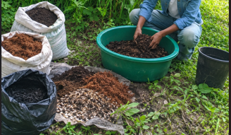 |  | 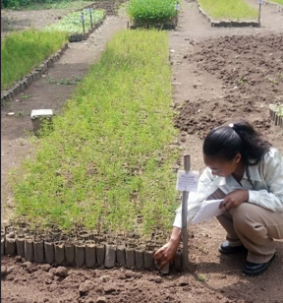
Figure 5. Preparation of potting media and filling of polythene tubes

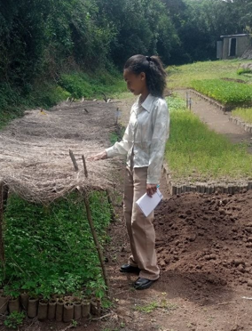 |  | 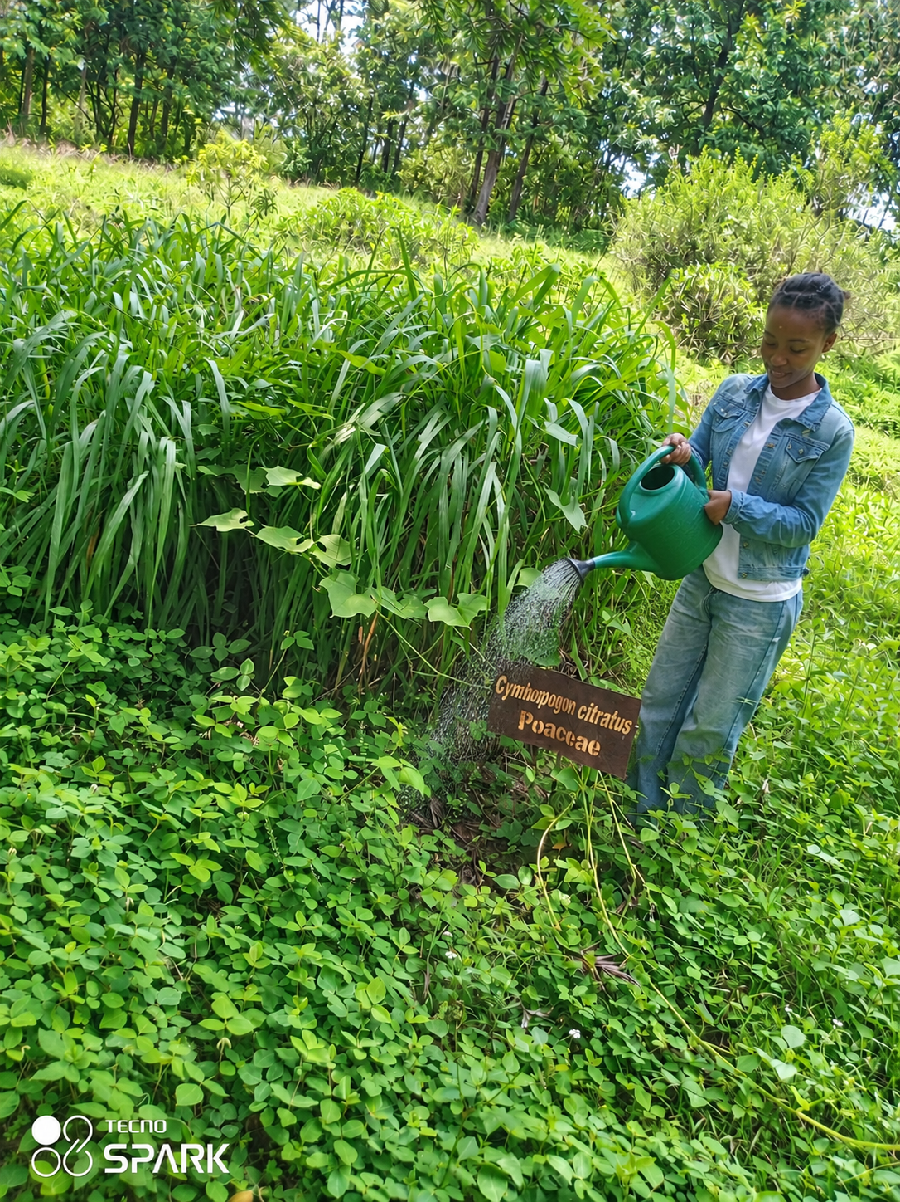
Figure 6. Sowing, pricking out and watering of seedlings

4.1.3 Observations and professional significance
Two points stood out during the nursery work. The first is that labelling is not an administrative afterthought but the core of the operation. A tube without a label holds a plant of unknown origin, and a plant of unknown origin has no conservation value even if it grows perfectly, because it cannot be traced back to a provenance, a collection date or a population. The staff were noticeably stricter about labels than about any other single practice in the nursery.
The second is that seedling losses are concentrated at two moments: immediately after pricking out, and immediately after transplanting to the field. Both are transitions rather than steady states. Hardening off exists to soften the second, and watering at the cool hours of the day exists to soften the first. This clarified a point that had been abstract in coursework, namely that survival in restoration planting is determined mostly in the nursery and not in the field.
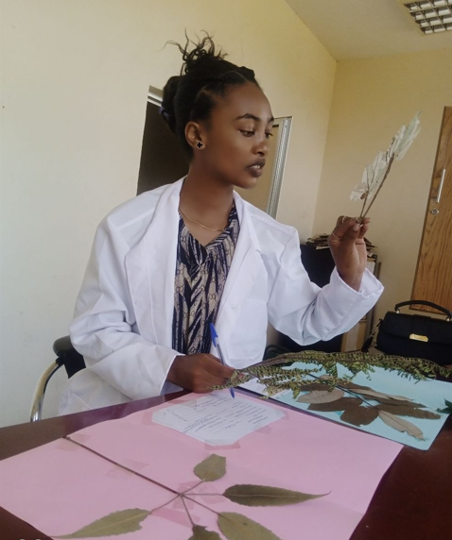
Figure 7. Hardening off and seedlings ready for transplanting

4.2 The Medicinal Plant Garden

4.2.1 Background
Medicinal plants occupy a particular position in Ethiopian conservation policy. A large share of the population relies on traditional medicine as a first line of health care, and the knowledge attached to these species is held mainly by practitioners and elders rather than in written form. Conserving the species without documenting the knowledge preserves only half of the resource. The garden addresses this through its medicinal plant block, supported by the much larger Wondo Genet medicinal field gene bank, where more than 320 medicinal species are held.

4.2.2 Activities performed
- Guided walk through the medicinal plant block with the responsible researcher.
- Identification of species and recording of scientific, Amharic and Afaan Oromo names.
- Observation of morphological characters useful for recognising each species in the field.
- Recording of the plant part used: leaf, root, bark, seed or whole plant.
- Discussion of traditional uses as reported by the staff, and of the conservation status of each species.
- Discussion of sustainable harvesting, since root and bark harvesting kills or severely damages the individual plant.
Table 7. Selected medicinal and economically significant species recorded at SBG
Scientific name | Afaan Oromo | Amharic | Habit | Significance and use
Vernonia galamensis | — | Ye'asraer areg | Herb / shrub | Symbolic plant of the garden; seed oil of industrial value; used traditionally
Hagenia abyssinica | Heexoo | Kosso | Tree | Indigenous; female flowers long used as an anti-parasitic remedy against tapeworm
Moringa stenopetala | — | Shiferaw | Tree | Indigenous; leaves used as a nutritional food and in traditional medicine
Millettia ferruginea | Birbiraa / Dhaadhituu | Berbera | Tree | Endemic to Ethiopia; nitrogen-fixing shade tree; seed used traditionally as a fish poison and pesticide
Acanthus sennii | — | Koshishilla | Shrub | Endemic to Ethiopia; decorative and used for live fencing
Names were recorded on site. A dash (—) means that no name was recorded for that language. Local names vary between districts and one name may be applied to more than one species.
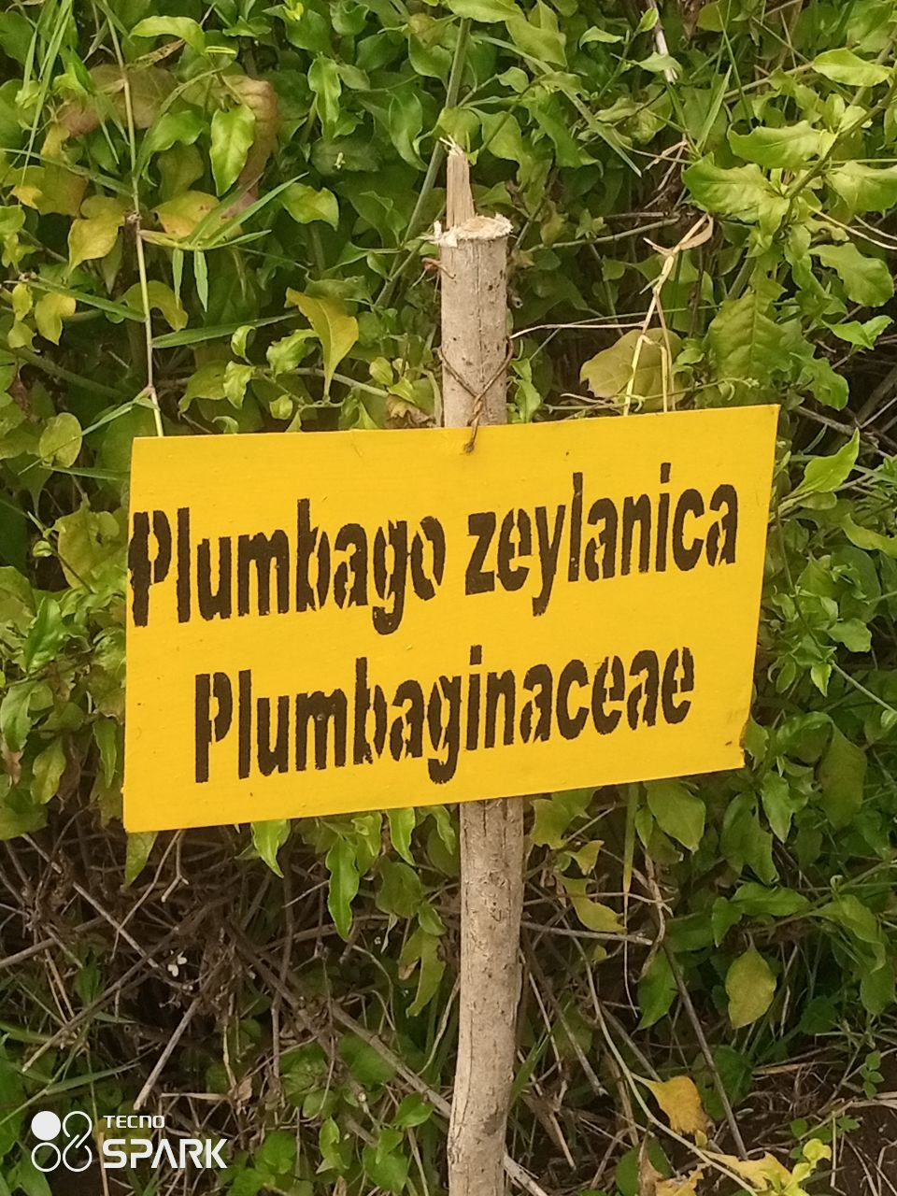 |  | 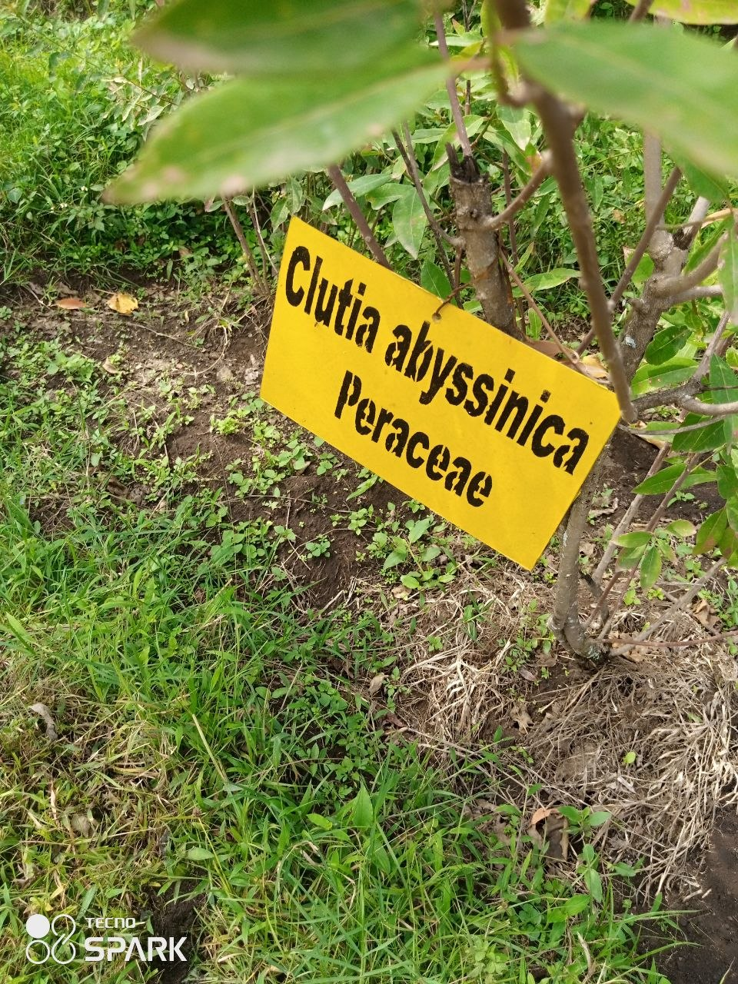
Figure 8. The medicinal plant in a garden |  | Figure 9. Another recorded medicinal species

4.2.3 Observations
The most useful discussion in this block concerned harvesting pressure. Where the useful part of a medicinal plant is the leaf, harvesting is compatible with survival. Where the useful part is the root or the bark, every harvest is a partial or total loss of the individual. This is the mechanism by which valued medicinal species become locally rare while surrounded by intact vegetation. Ex situ conservation in a garden block, combined with cultivation and domestication, is therefore not merely a backup for these species but a direct substitute for harvesting from the wild.

4.3 The Indigenous Plant Garden

4.3.1 Background
Indigenous plants are species that occur naturally in a given geographical region and have adapted over long periods to its climate, soils and biological community. They are the structural framework of the local ecosystem: they support the pollinators, birds and soil organisms that evolved alongside them, they stabilise soil and regulate water, and in the Ethiopian highlands they carry considerable cultural weight.

4.3.2 Species recorded
Table 8. Indigenous plant species recorded in the indigenous block
Afaan Oromo | Scientific name | Amharic | Habit | Ecological and cultural note
Birbirsa | Podocarpus falcatus | Zigba | Large tree | Indigenous conifer of the highland forest; valuable timber; slow growing
Bakkanniisa | Croton macrostachyus | Bisana | Tree | Fast-growing pioneer; widely used in traditional medicine and as shade
Ejersa | Olea europaea subsp. cuspidata | Woira | Tree | African wild olive; hard durable wood; culturally used for ritual fumigation
Gattiraa | Juniperus procera | Yehabesha tid | Tree | African pencil cedar; characteristic dry highland forest species
Heexoo | Hagenia abyssinica | Kosso | Tree | Also conserved in the medicinal block; upper highland species
Odaa / Qiltu | Ficus spp. | Varies with species | Very large tree | Sycamore fig; a cultural symbol of the Oromo people and the central heritage feature of the garden
Where the scientific name of a locally named species could not be confirmed on site, the name follows the usage of the garden staff and the records of the mini herbarium.

4.3.3 Observations
The indigenous block made one lesson concrete that lectures had only stated. Indigenous species are usually slower growing than the exotic species commonly planted in urban greening programmes, and this single trait explains much of the pressure against them. A city administration that needs visible results within a few seasons will choose a fast-growing exotic, and the indigenous species is progressively displaced from the landscape even though no one decided to remove it. The garden therefore performs a function that no fast planting programme can perform, which is to hold the slow species through the years in which they are not yet impressive.
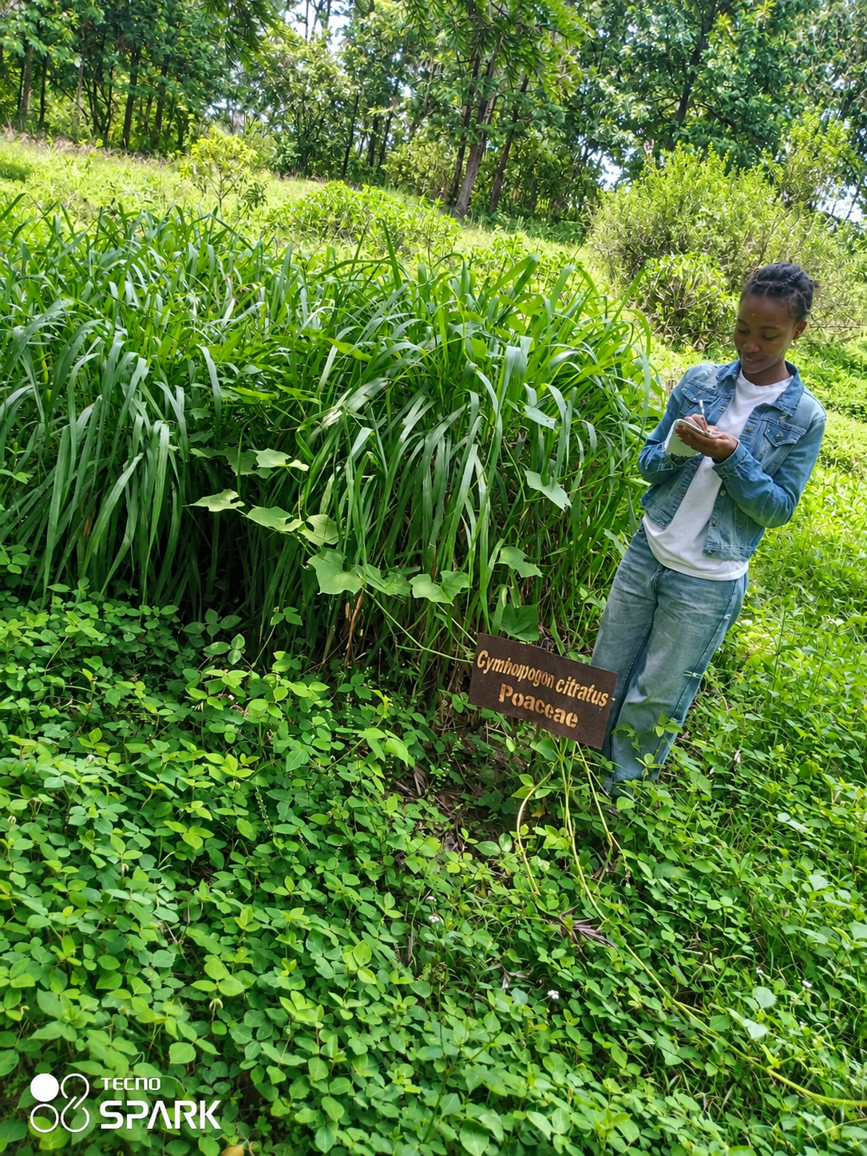
Figure 10. The indigenous plant block

4.4 The Endemic Plant Garden

4.4.1 Background
An endemic species is one whose entire natural distribution lies within a defined area. Ethiopia carries a high level of endemism, a consequence of its altitudinal range, its isolated highland massifs and its long geological history. The conservation implication is severe and simple: if an Ethiopian endemic is lost in Ethiopia, it is lost from the world. No population exists elsewhere to recolonise from, and no other country can take responsibility for it.

4.4.2 Species recorded
Table 9. Endemic and nationally significant species recorded in the endemic block
Afaan Oromo | Scientific name | Amharic | Habit | Note
Birbiraa / Dhaadhituu | Millettia ferruginea | Berbera | Tree | Endemic to Ethiopia; nitrogen-fixing; commonly retained as a shade tree in coffee systems
— | Acanthus sennii | Koshishilla | Shrub | Endemic to Ethiopia; showy red flowers; used for live fencing and ornament
Walleensuu | Erythrina brucei | Korchi | Tree | Endemic to Ethiopia; used for live fencing, shade and soil conservation
Lolchiisaa | Bersama abyssinica | Azamir | Tree / shrub | Recorded in the block as noted on site; widely used in traditional medicine
Boroqqaa | [to be confirmed with the SBG herbarium] | — | Tree | Recorded under its local name during the field walk; scientific name requires verification

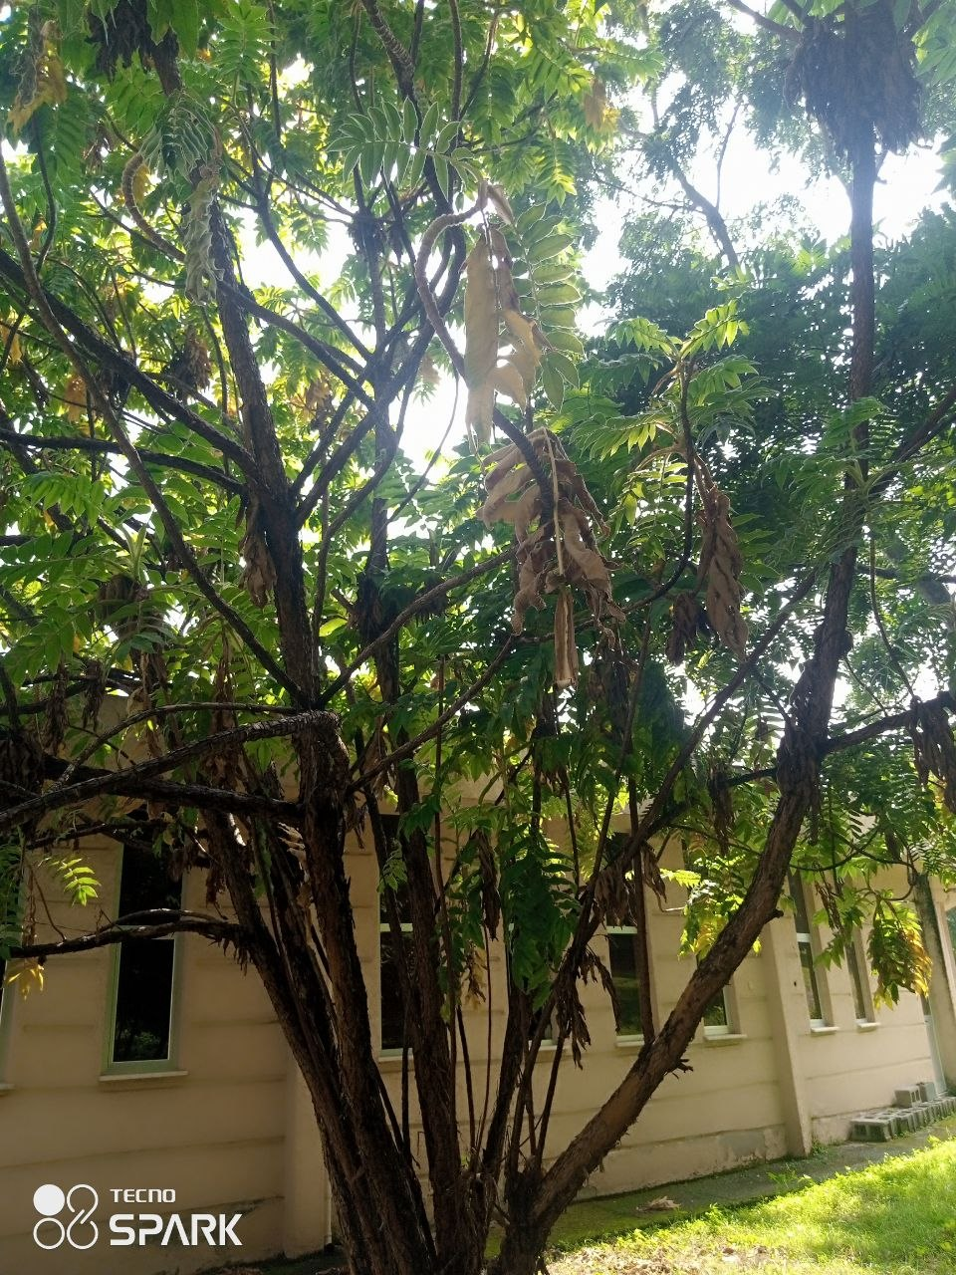
Figure 11. The endemic plant block

4.4.3 Observations
The endemic block also demonstrated the value of a botanical garden as an interpretation site rather than only a conservation site. A visitor who is told that a particular tree grows nowhere else on earth responds differently from a visitor who is told that it is a useful tree. The endemic block is, for this reason, the strongest ecotourism asset in the garden, and it is currently under-used in that role. This point is taken up again in Section 4.8.

4.5 Plant Taxonomy and Field Identification

4.5.1 Background
Plant taxonomy is the science of identifying, naming, describing and classifying plants. It provides the common language without which conservation cannot function, since two institutions can only cooperate over a species if they are certain they are discussing the same organism. Binomial nomenclature, in which each species carries a genus name and a specific epithet in Latin form, exists for this reason. The hierarchy applied during the attachment runs from kingdom, division, class, order and family down to genus and species.
Table 10. Taxonomic classification of selected species recorded at SBG
Rank | Hagenia abyssinica | Millettia ferruginea | Moringa stenopetala | Vernonia galamensis
Kingdom | Plantae | Plantae | Plantae | Plantae
Division | Magnoliophyta | Magnoliophyta | Magnoliophyta | Magnoliophyta
Class | Magnoliopsida | Magnoliopsida | Magnoliopsida | Magnoliopsida
Order | Rosales | Fabales | Brassicales | Asterales
Family | Rosaceae | Fabaceae | Moringaceae | Asteraceae
Genus | Hagenia | Millettia | Moringa | Vernonia
Species | H. abyssinica | M. ferruginea | M. stenopetala | V. galamensis

4.5.2 Characters used in field identification
Table 11. Vegetative and reproductive characters used for field identification
Character group | Features examined | Why it is useful
Habit | Tree, shrub, herb, climber; branching pattern; crown shape | First filter that narrows the possibilities quickly
Leaf | Simple or compound; margin; venation; apex and base; surface hairs | Available in all seasons; the main working character
Leaf arrangement | Alternate, opposite or whorled; presence of stipules | Strongly diagnostic at family level
Bark and stem | Colour, texture, fissuring, exudate, latex | Useful for large trees whose leaves are out of reach
Flower | Symmetry; number of parts; inflorescence type; colour | Most reliable, but only available in season
Fruit and seed | Pod, capsule, berry, drupe; dehiscence; seed appearance | Often persists longer than the flower
Odour and taste | Crushed leaf odour, resinous smell, latex | Used routinely by the staff; rarely taught in class

4.5.3 Observations
Field identification proved to be the single largest gap between classroom preparation and site practice. In coursework, identification is presented as the application of a dichotomous key to a specimen in hand. In the field, the staff rarely reached for a key. They worked from a rapid assessment of habit, bark, leaf arrangement and crushed-leaf odour, and arrived at the correct name in a few seconds; the key was used only to settle a dispute or to confirm an unfamiliar specimen.
This is not a criticism of the key method, which is the correct method for a beginner and for an unknown plant. It is a recognition that identification is a pattern skill built by repetition, and that repetition can only be gained in the field. The number of contact hours spent handling living plants is a better predictor of identification ability than the number of hours spent on taxonomy theory.
Figure 12. Field identification practice using vegetative characters

4.6 Herbarium Specimen Preparation

4.6.1 Background
A herbarium is a collection of pressed, dried, mounted and labelled plant specimens, systematically arranged for reference. It is the permanent physical evidence base of botany. A photograph records what a plant looked like; a herbarium specimen preserves the plant itself, so that a researcher a century later can re-examine the characters, extract material for analysis, and confirm or correct the original determination. The mini herbarium at SBG holds more than 250 dried specimens and supports the plant identification service offered to researchers.

4.6.2 Procedure followed
The full technical sequence was carried out under the supervision of the garden botanist.
- Collection. A representative portion of the plant was cut, including leaves and, where available, flowers, fruits and seeds, since a sterile specimen has limited determinative value. For herbs the whole plant including the root system was taken. A collection number was written on the specimen tag and in the field notebook at the moment of collection.
- Field recording. Locality, habitat, altitude, habit, height, flower and fruit colour, local name, collector and date were recorded on the spot, because characters such as colour and odour are lost on drying.
- Pressing. The specimen was arranged on newspaper with at least one leaf turned over to expose the lower surface, placed between blotting sheets and corrugated boards, and the press was tightened evenly.
- Drying. The press was kept in a well-ventilated place and the newspapers were changed regularly during the first days, when moisture release is highest, to prevent fungal growth and blackening.
- Mounting. The dried specimen was fixed to a standard herbarium sheet using glue and gummed strips, with the lower right corner left free for the label.
- Labelling. A label carrying the full record (Table 12) was completed and fixed in the lower right corner of the sheet.
- Protection and filing. The sheet was treated against insect attack, placed in a species folder and filed by family and genus according to the arrangement of the herbarium.
Table 12. Standard information recorded on a herbarium label
Field | Content recorded
Institution | Ethiopian Biodiversity Institute, Shashemene Botanical Garden
Scientific name | Genus, specific epithet and author where known
Family | Botanical family of the specimen
Local names | Amharic and Afaan Oromo names as reported on site
Locality | Region, zone, woreda, specific site and block
Coordinates and altitude | Latitude, longitude and elevation in metres above sea level
Habitat | Vegetation type, slope, soil and associated species
Habit and description | Tree, shrub or herb; height; flower and fruit colour when fresh
Uses | Traditional or economic use as reported
Collector and number | Name of collector and collection number
Date of collection | Day, month and year
Determined by | Name of the botanist who confirmed the identification, and the date

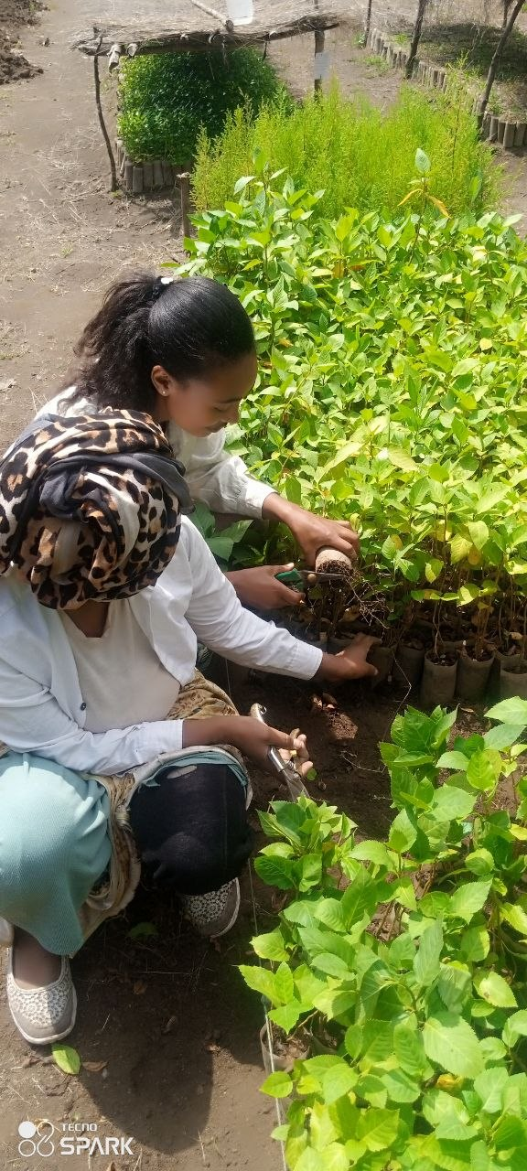
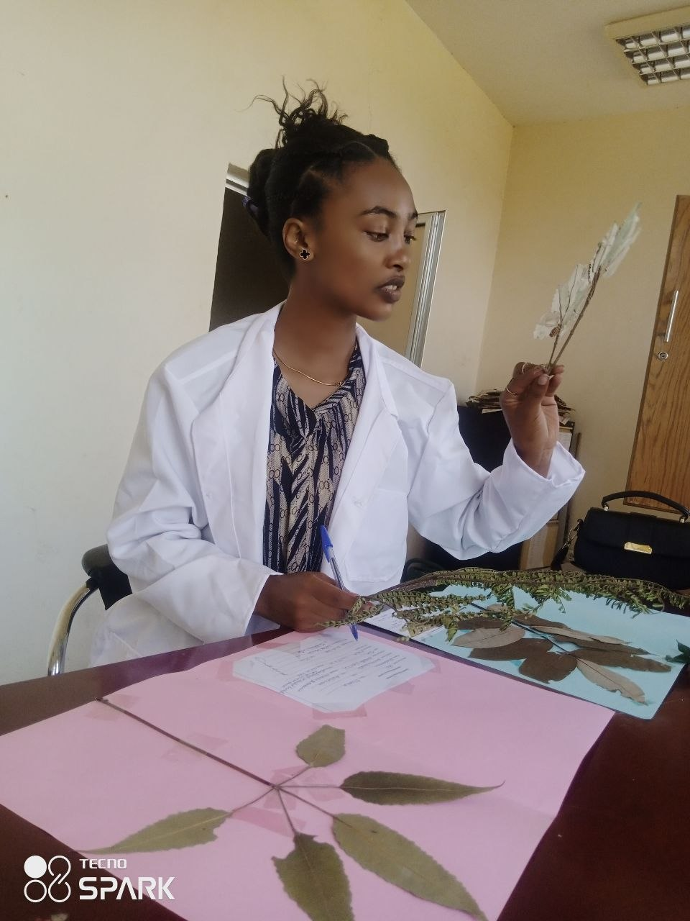
Figure 13. Collection of plant specimens in the field |  | Figure 14. Pressing and drying of specimens

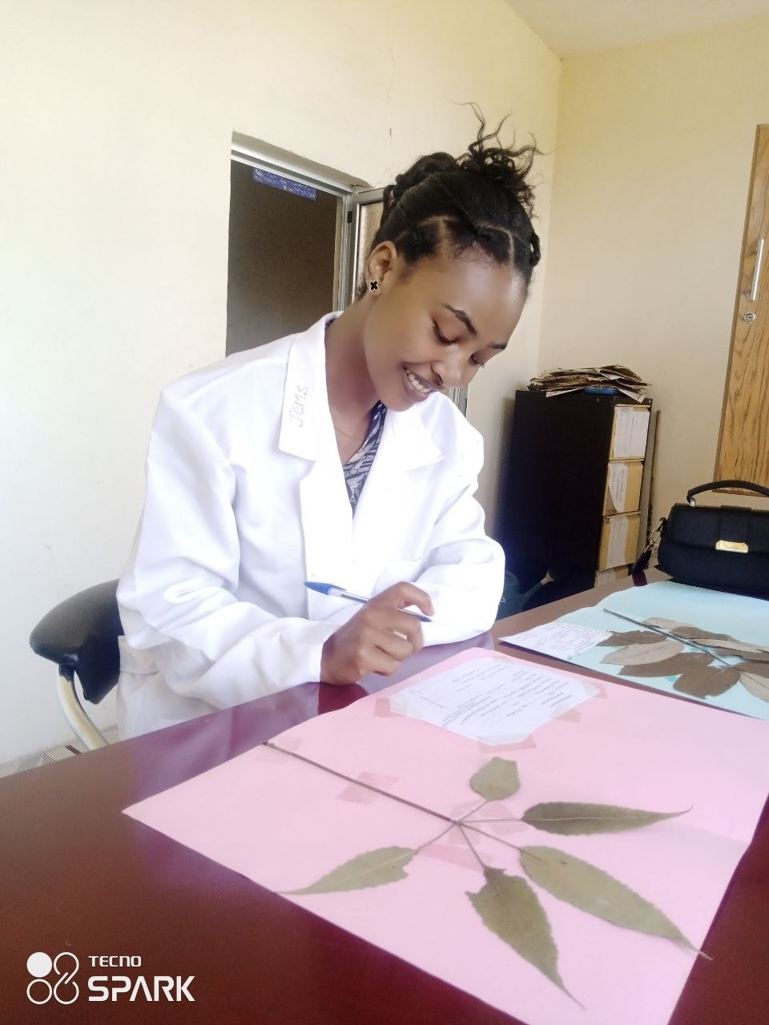
Figure 15. Mounted and labelled herbarium sheets

4.6.3 Observations
The herbarium work reinforced the lesson already noted in the nursery. A specimen without a complete label is not a scientific object, whatever the quality of the pressing. The garden botanist was explicit on this point: a beautifully mounted sheet with an incomplete label is a decoration, while a poorly pressed sheet with a full label remains usable data. The discipline required is not manual skill but the habit of writing down information at the moment it is still available.

4.7 Compost Production

4.7.1 Background
Compost is the stable organic material produced by the controlled decomposition of biodegradable plant and animal residues. At the garden, composting serves two purposes at once. It converts the substantial volume of organic waste generated by pruning, weeding and leaf fall into a resource instead of a disposal problem, and it supplies the organic fraction of the nursery potting media, reducing dependence on soil taken from elsewhere.

4.7.2 Materials and procedure
Table 13. Materials used and layering sequence for compost preparation
Material | Type | Role in the process
Dry leaves, straw, crop residues | Brown, carbon-rich | Supplies energy for the decomposer organisms and maintains aeration
Green plant material, fresh grass, weeds | Green, nitrogen-rich | Supplies nitrogen for microbial multiplication and drives heating
Animal manure | Green, nitrogen-rich | Introduces decomposer organisms and accelerates the start of the process
Top soil | Inoculant | Thin layers introduce soil micro-organisms and reduce odour
Water | Moisture | Maintains moisture at about the dampness of a wrung-out cloth
Wood ash (where used) | Mineral | Adjusts acidity and adds potassium

The heap was built by alternating brown and green layers of roughly equal thickness, with a thin layer of soil after every few layers, watering each layer as it was laid. A stick was inserted through the centre of the heap so that the internal condition could be checked by withdrawing it and testing its warmth and moisture. The heap was turned at intervals to restore aeration and to bring the outer material into the hot centre.

4.7.3 Assessment of maturity
Mature compost was assessed by four signs taught on site: it is dark brown to black in colour; it is crumbly and uniform in texture, with the original materials no longer recognisable; it smells of forest soil rather than of decaying matter; and it has cooled to ambient temperature, indicating that the readily available material has been consumed.
 |  | 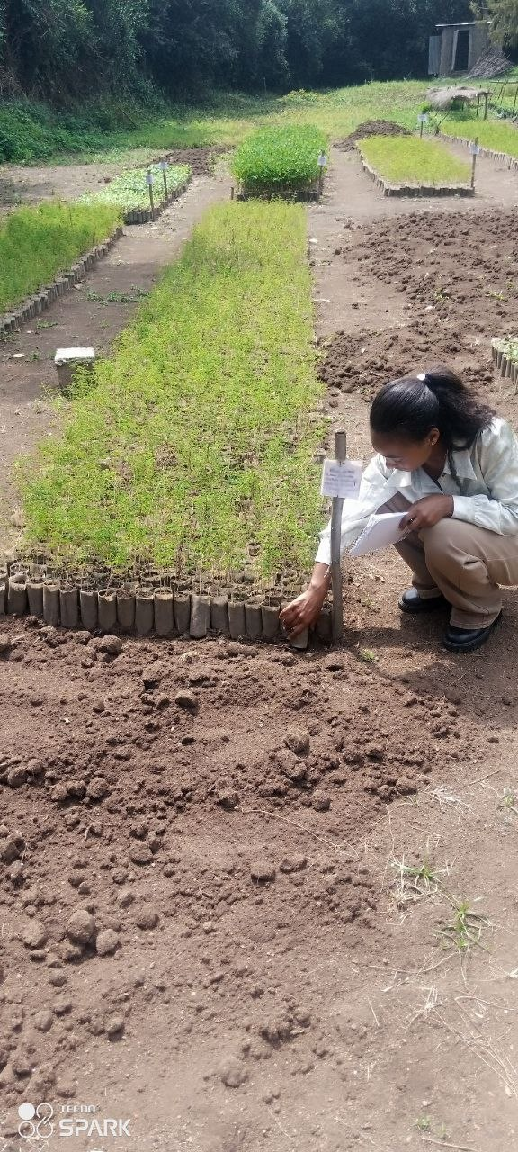
Figure 16. Collection and layering of compost materials |  | Figure 17. Turning of the heap and the matured compost
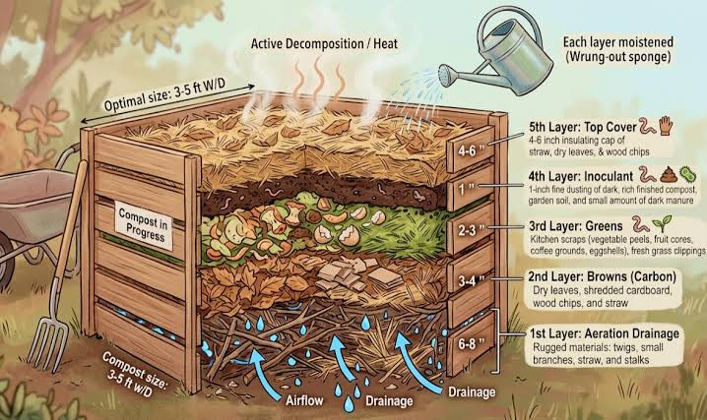  Figure 16. Collection and layering of compost materials |  | 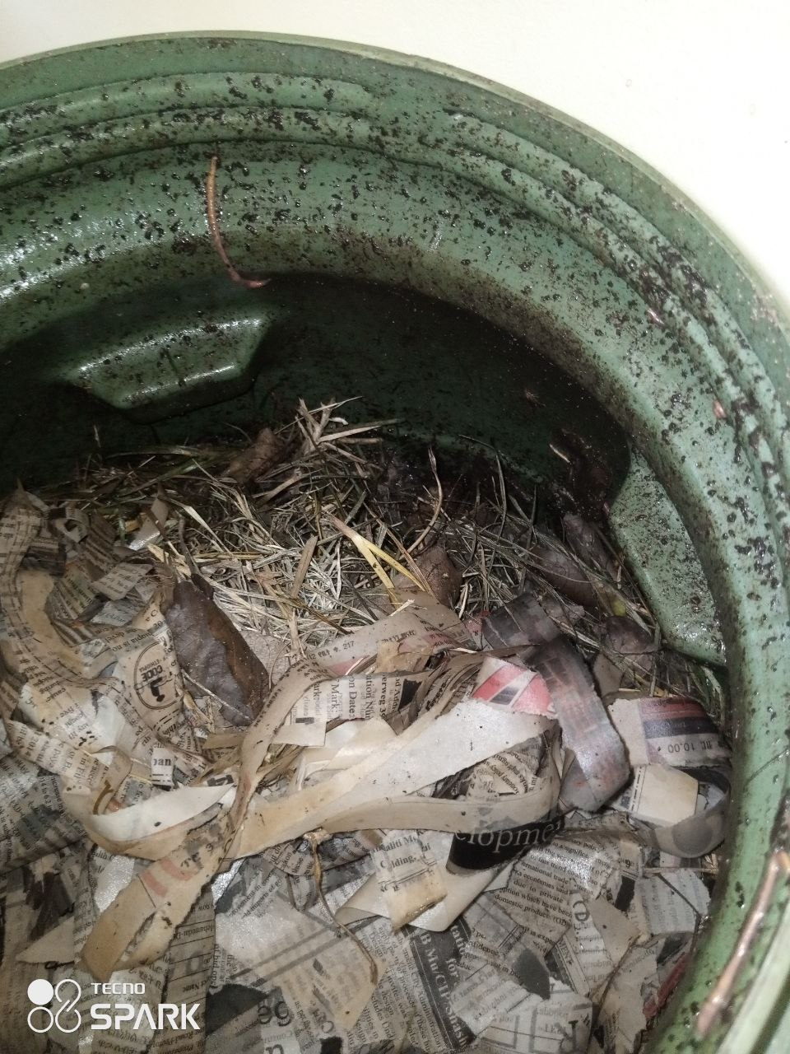  Figure 17. Turning of the heap and the matured compost

4.7.4 Observations
The most common practical fault observed was the moisture balance. A heap that is too wet loses aeration, turns anaerobic and produces the sour smell that indicates the process has gone wrong, while a heap that is too dry simply stops. Neither fault is difficult to correct once recognised, but both are easy to create. The stick test is a simple field method worth carrying into any community training programme, because it requires no equipment and can be demonstrated in a minute.

4.8 Ecotourism, Environmental Education and Community Service

4.8.1 Rationale for treating this as a working area
Two of the four stated objectives of the garden concern education, public awareness and the promotion of tourism. A report prepared by a student of ecotourism and biodiversity conservation would be incomplete if it treated the garden only as a plant conservation facility. This section therefore examines the garden as a visitor destination and as a community institution.

4.8.2 Attraction sites and their interpretation status
Table 14. Attraction sites of SBG and their ecotourism interpretation status
Site or feature | Ecotourism value | Observed interpretation provision
Qiltu heritage tree | A very large Ficus of more than four metres in diameter with a wide crown. It survived a lightning strike and attempts to fell it, and is now recovering. It carries deep cultural significance for the Oromo people and currently supports a camping service. | Strong story; limited on-site interpretation observed
Melka Oda River | The only permanent river in the area, crossing the centre of the garden. It supplies the nursery and supports the community downstream. | Scenic value high; signage limited
Endemic plant block | Species that exist nowhere else in the world. The strongest single interpretive message available to the garden. | Labelled as a collection rather than presented as a story
Acacia and Celtis trees | Support a large bird population by providing nesting shelter, offering a direct bird-watching opportunity. | No dedicated bird-watching provision observed
Richya albersi | A highland species growing along the river outside its natural habitat, assumed to have been carried down by the river. It is not found elsewhere around Shashemene. | An unusual botanical story, not currently interpreted
Cultural event space | Hosts Abagada and Hara Sinke ceremonies, exhibitions, festivals, weddings and birthday celebrations. | Actively used; a significant community link
Flower and rose gardens | High aesthetic appeal, the natural photographic focus for general visitors. | Well maintained and popular

4.8.3 Services observed
- Herbarium and plant identification service provided to researchers by experienced botanists.
- Training for field workers, community members and practitioners on biodiversity conservation and management, herbarium technique, nursery management, seed collection and invasive plant management.
- Advisory services on conservation and on the control of invasive plants.
- Seedling provision on demand for conservation and awareness purposes.
- Recreation, camping and event hosting for the urban community of Shashemene.
- Environmental education visits by school groups, accompanied by garden educators.
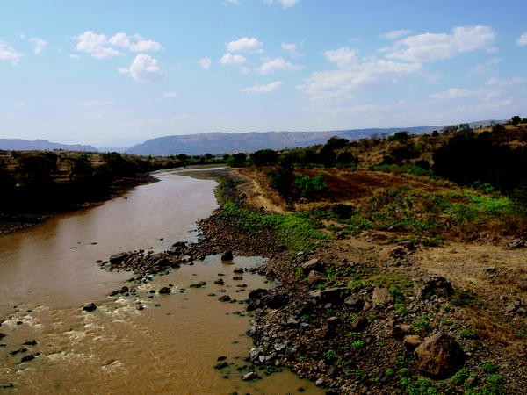
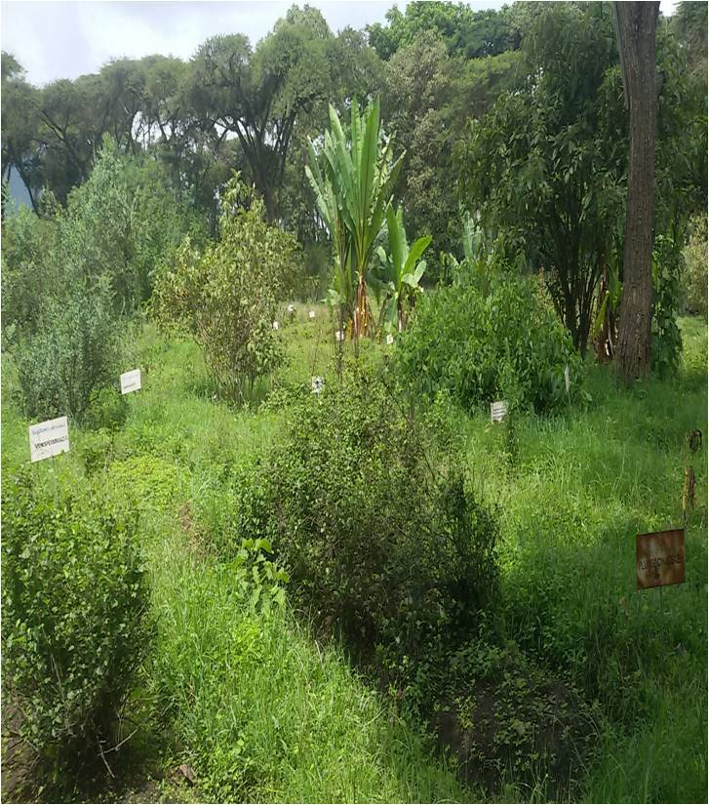
Figure 18. SBG compound |  | Figure 19. The Melka Oda river crossing the garden

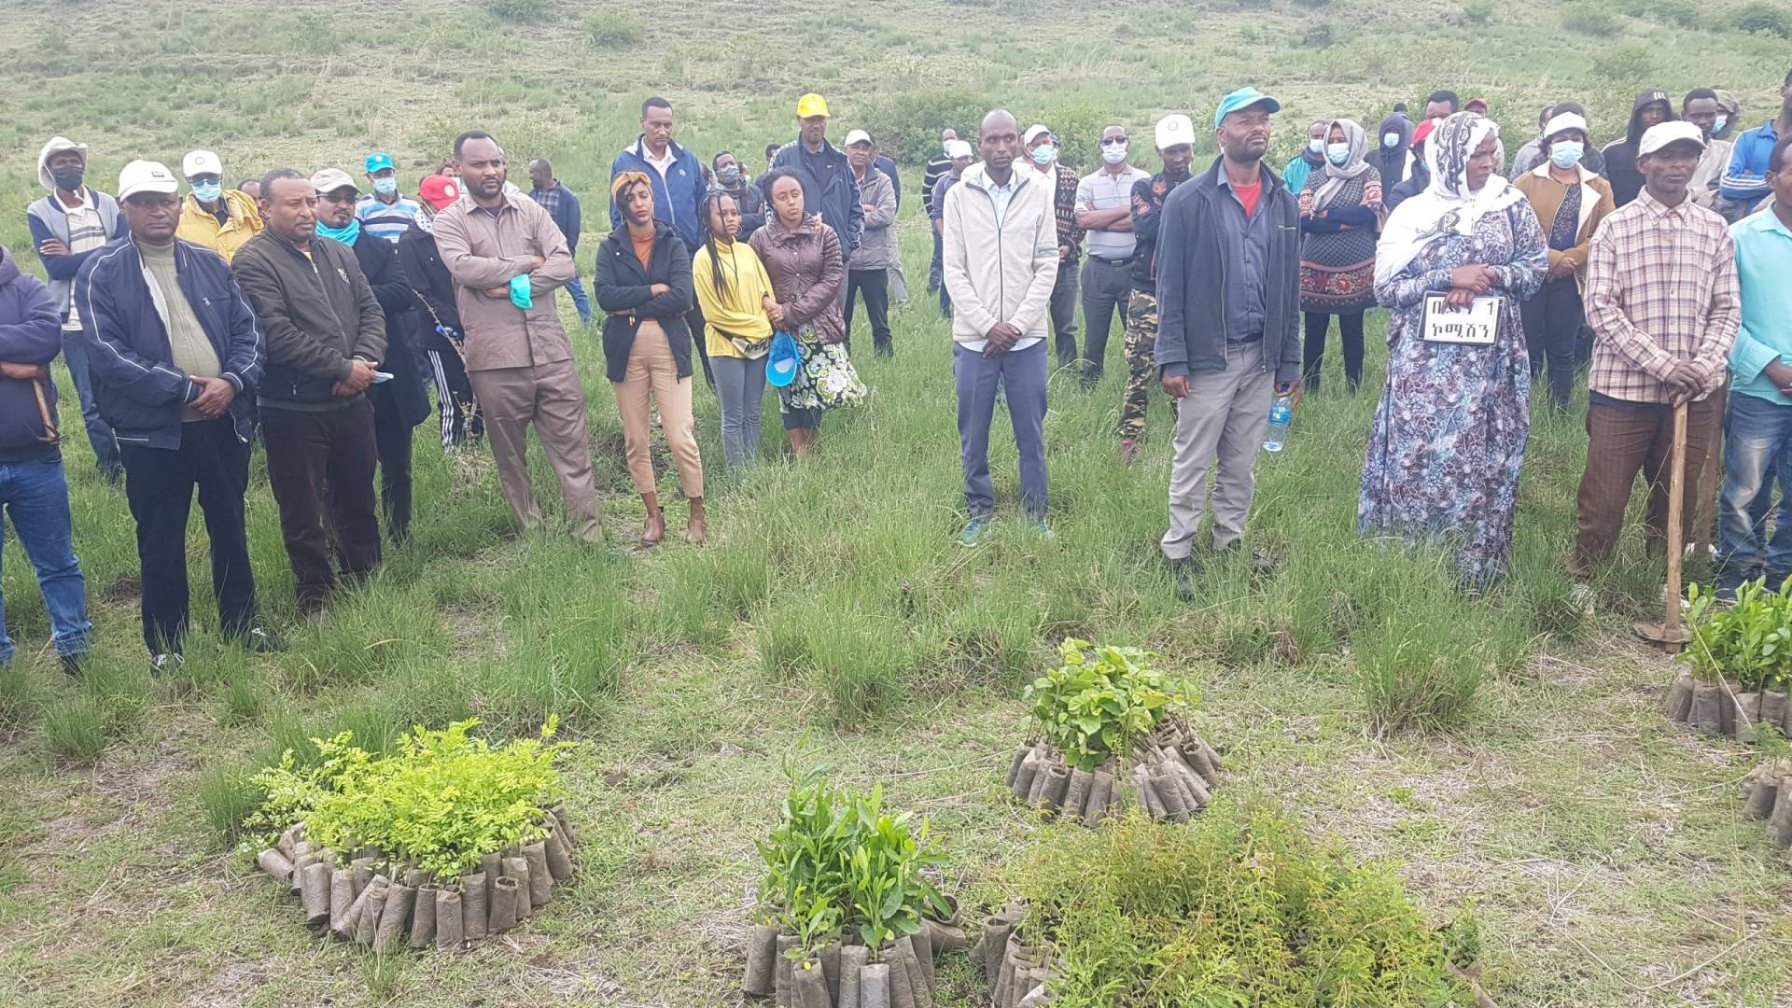
Figure 20. SBG Environmental education and community service activities

4.8.4 Assessment
The garden holds strong ecotourism assets and currently converts them into visitor value below their potential. The limiting factor observed is interpretation rather than infrastructure. The Qiltu tree is an example. As it stands, a visitor sees a very large fig tree. With a single well-designed panel, the same visitor would learn that the tree is a cultural symbol of the Oromo people, that it survived a lightning strike and an attempt to fell it, and that it is now healing and providing shade for a camping service. The physical asset is identical; the experience is not.
The same applies to the endemic block. A plant label giving a scientific name serves the botanist. A panel stating that these species grow nowhere else on earth and that Ethiopia alone is responsible for them serves the visitor, and converts a plant collection into a conservation message. This is the practical meaning of interpretation as taught in the ecotourism courses of the department, and the garden offers an unusually clear case for applying it.
Principal ecotourism finding of this attachment
The constraint on visitor value at SBG is interpretation, not attractions. The attractions already exist and are of high quality. What is missing is the layer of storytelling that turns a specimen into a message, and that layer is the least expensive investment available to the garden.
An interpretation plan for the Qiltu site, the endemic block and the Melka Oda river corridor is proposed in Chapter 8 as the single highest-return intervention identified during this attachment.

4.9 Digital Documentation Portfolio
A recurring theme of this attachment is that conservation work is only as durable as its records. That observation was applied to the attachment itself. Alongside this printed report, a digital documentation portfolio was prepared and published at https://ebi-intern.pages.dev, so that the full evidence base of the attachment remains accessible after the printed copy has been filed. It is hosted on a static web platform at no cost to the host institution and requires no maintenance budget.
Three considerations justified the effort. A printed report can carry only a small selection of photographs, while the attachment generated a far larger visual record. The host institution has an interest in retaining documentation of the work carried out on its site, and a link is easier to retain than a bound copy. And the exercise is itself a demonstration of low-cost digital documentation for a conservation centre.
Table 15. Structure and content of the digital documentation portfolio
Section | Content | Purpose
Overview | Profile of EBI and SBG, attachment period, working areas covered | Orientation for a first-time visitor to the site
Photo gallery | Full captioned photographic record organised by working area | Holds the images that the printed report cannot carry
Species records | Medicinal, indigenous and endemic species tables with names, habit and uses | Searchable reference version of Tables 7, 8 and 9
Herbarium records | Specimen sheets with their full label data | Documents the specimens prepared during the attachment
Field journal | Daily notes and observations from the field notebook | Provides the evidence trail behind the weekly log
Ecotourism assessment | Attraction site survey and interpretation proposals | Extended version of Section 4.8
Downloads | This report and the species data in printable form | Allows the host institution to retain a copy

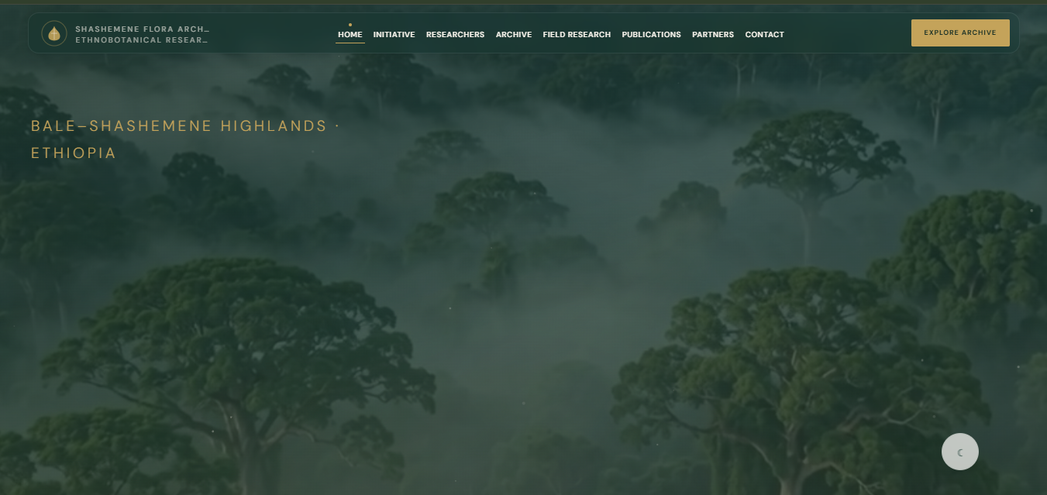
Figure 21. Home page of the digital documentation portfolio

The portfolio is offered to the Ethiopian Biodiversity Institute and to Shashemene Botanical Garden for their use. It contains no confidential institutional information, and any material the host institution wishes to remove or amend can be adjusted on request.

4.10 Weekly Activity Log
The following log summarises the attachment week by week and is cross-referenced to the tables and figures of this chapter.
Table 16. Weekly activity log of the practical attachment
Week | Dates | Activities performed | Output and evidence
1 | 1/07/2026 | Reporting and induction; orientation tour of the compound and the eleven conservation blocks; briefing on the mandate of EBI and the history of SBG; safety and conduct rules; assignment of supervisors | Orientation notes; institutional profile data; Figures 1 and 2
2 | 8/07/2026 | Nursery work: bed preparation, media sieving and mixing, tube filling, seed sorting and labelling, sowing | Tables 5 and 6; Figures 4 and 5
3 | 15/07/2026 | Nursery work continued: pricking out, watering regime, weeding, root pruning, shade adjustment, hardening off | Figures 6 and 7; nursery observations
4 | 22/07/2026 | Medicinal plant block: guided identification, recording of names, plant parts used and traditional applications; discussion of sustainable harvesting | Table 7; Figures 8 and 9
5 | 29/07/2026 | Indigenous and endemic blocks: species identification and recording, habit and habitat notes, conservation status discussion | Tables 8 and 9; Figures 10 and 11
6 | 5/08/2026 | Plant taxonomy: classification exercises, practice with vegetative and reproductive characters, independent identification test | Tables 10 and 11; Figure 12
7 | 5/08/2026 | Herbarium: specimen collection, pressing, drying, mounting, labelling and filing under supervision of the garden botanist | Table 12; Figures 13, 14 and 15
8 | 5/08/2026 | Compost site: material collection, heap construction and layering, moisture management, turning, maturity assessment | Table 13; Figures 16 and 17
9 | 5/08/2026 | Ecotourism assessment: attraction site survey, interpretation review, observation of school visits and community activities | Table 14; Figures 18, 19 and 20
10 | 5/08/2026 | Compilation: organisation of photographs and records, construction of the digital portfolio, drafting of this report, review with supervisor | Figure 21; portfolio; draft report

Host supervisor name | Signature | Date

4.11 Skills and Competences Acquired
Table 17. Skills and competences acquired during the attachment
Category | Specific competence gained | Where acquired
Technical: propagation | Media formulation, tube filling, sowing depth judgement, pricking out, watering regime, hardening off | Nursery, Weeks 2 and 3
Technical: identification | Use of habit, leaf, bark and odour characters; application of the taxonomic hierarchy; binomial nomenclature in practice | Blocks and field walks, Weeks 4 to 6
Technical: herbarium | Collection, pressing, drying, mounting, labelling and filing to institutional standard | Mini herbarium, Week 7
Technical: soil and waste | Compost layering, carbon-to-nitrogen balance, moisture control, turning, maturity assessment | Compost site, Week 8
Conservation practice | Distinction between in situ and ex situ conservation in operational terms; accession and provenance discipline | Across all blocks
Ecotourism practice | Attraction inventory, interpretation assessment, visitor flow observation, community engagement | Week 9
Documentation | Field notebook discipline, systematic photographic recording, species data tabulation, digital publication | Throughout; Week 10
Professional and transferable | Teamwork with professional staff, communication in Afaan Oromo and Amharic with community members, punctuality, initiative, report writing | Throughout

5. REVIEW OF OBJECTIVES AGAINST ACHIEVEMENT
This chapter reviews each objective set in Chapter 2 against what was actually achieved, and then compares the classroom preparation of the department with the work encountered on site, as required by the university reporting format.

5.1 Achievement of the Specific Objectives
Table 18. Review of objectives against achievement
No. | Objective | Status | Evidence and remark
1 | Nursery and seedling production skill | Achieved | Participated in all ten operations listed in Table 5 and worked independently on tube filling, watering and weeding by the end of Week 3
2 | Identify and document medicinal plants | Achieved | Species recorded in Table 7 with local names, plant parts used and reported applications
3 | Identify indigenous plants and ecological role | Achieved | Species recorded in Table 8; the growth-rate argument in Section 4.3.3 was drawn from field discussion
4 | Record endemic species | Achieved, one open record | Table 9 completed; one local name remains to be matched to a scientific name from the herbarium records
5 | Apply plant taxonomy in the field | Partially achieved | Classification exercises completed (Table 10); independent field identification reached about fifteen species, but confidence remains low for sterile specimens
6 | Herbarium technique | Achieved | Full sequence carried out from collection to filing; mounted sheets submitted to the mini herbarium
7 | Compost production | Achieved | Heap built, turned and assessed; maturity indicators learned and applied
8 | Ecotourism assessment of the garden | Achieved | Attraction inventory and interpretation assessment completed in Table 14; recommendations developed in Chapter 8
9 | Digital documentation portfolio | Achieved | Portfolio published at ebi-intern.pages.dev and offered to the host institution
10 | Professional and transferable skills | Achieved | Summarised in Table 17 and confirmed by the host supervisor

Objective five is reported as partially achieved. It would have been easy to record it as fully achieved, since fifteen species were in fact identified. The honest position is that identification of a labelled plant in a garden block is a much weaker test than identification of an unlabelled sterile specimen in natural vegetation, and the second ability was not reached during this attachment.

5.2 Review of the Learning Objectives
The five learning objectives set in Section 2.3 were reviewed at the end of the attachment against the activities actually carried out.
Field identification of fifteen species. Met for labelled plants in the garden blocks: about fifteen species were identified in the field (Tables 7 to 9). It was not met for unlabelled sterile specimens in natural vegetation, which is why objective five in Table 18 is reported as partially achieved.
In situ and ex situ conservation. Met through examples seen on the site. The eleven conservation blocks and the field gene banks illustrate ex situ conservation, while the Aje area closure and the Gara Iffa restoration site show conservation work carried out on the landscape itself. The two operate as one programme rather than as alternatives.
A herbarium sheet to SBG standard. Met. The full sequence from collection to filing was carried out under the garden botanist, and the mounted and labelled sheets were submitted to the mini herbarium.
Public access versus collection integrity. Met through observation. Camping under the Qiltu tree, cultural ceremonies, festivals and school visits all take place on the same seventeen hectares as the living collections, and school groups are accompanied by garden educators. The trainee concluded that the limiting factor is interpretation rather than access control.
Adequacy of the coursework. Met. The theoretical foundation proved sound, and the three gaps that were found are set out in Section 5.4.

5.3 Comparison of Classroom Learning and Real Site Work
Table 19. Comparison of classroom learning and real site work
Theme | As learned in the classroom | As encountered at SBG
Plant identification | Presented as the systematic application of a dichotomous key to a specimen | Practised as rapid pattern recognition from habit, bark, leaf arrangement and odour; the key is reserved for disputes and unknowns
Conservation categories | In situ and ex situ conservation defined as contrasting alternatives | Operated together in one institution: garden blocks, field gene banks and two outreach restoration sites form a single programme
Propagation | Germination requirements and dormancy treated as theory | Governed in practice by media quality, watering timing, shade adjustment and hardening off, which are rarely covered in detail in class
Record keeping | Treated as an administrative step after the scientific work | Treated as the scientific work itself; an unlabelled tube or an unlabelled sheet has no institutional value
Composting | Presented as an agricultural soil fertility topic | Operated as waste management and nursery input supply at the same time
Ecotourism | Interpretation, carrying capacity and visitor management taught as concepts | Encountered as a live problem: strong attractions with limited interpretation, and cultural use running alongside conservation use
Community relations | Discussed in general terms as participation | Observed as concrete practice: training, seedling supply, school visits and hosting of cultural ceremonies

5.4 The Gap Between Real Work and Class Learning
Three gaps were identified during the attachment. They are stated plainly because identifying them is one of the purposes of the reporting format.

5.4.1 The identification confidence gap
The programme provides a solid theoretical grounding in taxonomy but limited handling time with living plants. The consequence is a graduate who can explain the taxonomic hierarchy but hesitates in front of an unlabelled tree. Identification is a repetition skill, and repetition cannot be delivered by lecture.

5.4.2 The documentation discipline gap
Coursework treats data recording as a step that follows the real work. Institutional practice treats it as the substance of the work. This is not a difference of emphasis but a difference of definition, and it took direct exposure to an operating collection to understand it.

5.4.3 The visitor management gap
The department carries ecotourism in its name, yet the practical management of visitors at a live conservation site, meaning interpretation design, route planning, carrying capacity, cultural use and the negotiation between access and collection integrity, is encountered mainly in theory. SBG demonstrated that these are daily operational decisions, not planning abstractions.

6. CHALLENGES ENCOUNTERED
The following challenges arose during the attachment. They are reported together with the measures taken, since the response to a difficulty is part of the professional record.
Table 20. Challenges encountered and measures taken
No. | Challenge | Effect on the work | Measure taken
1 | Difficulty in identifying species with similar vegetative characters, particularly where two species shared leaf form and arrangement | Slowed recording and produced initial misidentifications | Repeated field walks with the botanist; comparison against mini herbarium specimens; use of bark and odour as additional characters
2 | Many species were not in flower or fruit during the attachment period | Reproductive characters, the most reliable ones, were unavailable | Relied on vegetative characters and on staff knowledge; marked uncertain records as requiring confirmation
3 | Limited availability of Ethiopian flora references and identification guides on site | Independent verification of names was constrained | Cross-checked against block labels and the judgement of the garden botanist; left one record open rather than guessing
4 | Short attachment period relative to the biological cycles observed | Germination, hardening off and compost maturation could not all be followed to completion | Followed different batches at different stages in parallel to observe the full sequence
5 | Weather interruption of field activities | Some field days were shortened | Rescheduled outdoor work and used interrupted periods for herbarium, notebook and data organisation
6 | Shortage of practical materials such as presses, blotting paper and labels at peak demand | Specimen preparation was constrained at times | Scheduled herbarium work in turn with other users; substituted newspaper for blotting sheets where acceptable
7 | Difficulty in collecting complete specimens from very large trees | Fertile material out of reach | Collected fallen material where its identity could be established with certainty; recorded the limitation on the label
8 | Absence of a written accession record for some conservation block individuals | Provenance could not always be traced | Recorded the observation and raised it as a recommendation in Chapter 8

7. CONCLUSION
The practical attachment carried out at the Ethiopian Biodiversity Institute, Shashemene Botanical Garden, met the purpose for which the university designed the programme. Over the attachment period the trainee worked inside an operating national conservation institution rather than observing one, and carried out real tasks in nursery production, species documentation, taxonomy, herbarium preparation, composting and ecotourism assessment.
The technical outcomes are recorded in Chapter 4 and summarised in Table 17. The trainee is now able to prepare potting media and raise seedlings through the full nursery cycle, to identify a working set of indigenous, endemic and medicinal species of the region, to classify them according to the standard taxonomic hierarchy, to prepare a herbarium sheet that meets institutional standards, to build and assess a compost heap, and to conduct a structured interpretation assessment of a visitor site.
The most significant professional lesson was conceptual rather than technical. Conservation is a documentation discipline before it is a planting discipline. A seedling with no accession record, a specimen with no collection label and an attraction with no interpretation panel are all incomplete in institutional terms, however healthy the seedling or however impressive the attraction. The rigour that the staff applied to labels and records, which might appear bureaucratic from outside, is the mechanism that converts biological material into conserved biodiversity.
The second lesson concerns the relationship between conservation and tourism. These are frequently presented as being in tension, and at the level of site pressure they are. But at Shashemene the relationship observed was mutual: the visitor function generates the public constituency, the community relationship and the institutional visibility on which conservation depends for long-term support, while the conservation function supplies the content that makes the visit worth making. A botanical garden is one of the clearest demonstrations available in Ethiopia that these two mandates can be operated on the same seventeen hectares.
Finally, the attachment identified where the academic preparation of the department is strong and where it is thin. The theoretical foundation in conservation biology, taxonomy and tourism concepts proved sound and directly applicable. The gaps lie in field identification confidence, in documentation discipline and in the operational side of visitor management, and they are addressed in the recommendations that follow.

8. RECOMMENDATIONS
The recommendations below are grouped by the party to whom they are addressed, and each is stated so that it can be acted upon rather than merely noted.

8.1 To the Host Institution: Ethiopian Biodiversity Institute and SBG
- Complete and digitise the accession records of the conservation blocks. Each conserved individual should carry an accession number linked to a record of provenance, collection date, collector and source population. Without this link the living collection functions as a display rather than as a conservation resource.
- Invest in interpretation before infrastructure. The single highest-return intervention identified is a small set of well-designed interpretive panels at the Qiltu heritage tree, the endemic plant block and the Melka Oda river corridor, in Afaan Oromo, Amharic and English. This would convert existing features into experiences at a fraction of the cost of any new construction.
- Present the endemic block as the flagship of the garden. Species that grow nowhere else in the world are the strongest conservation message available to any Ethiopian institution, and at present the block is labelled as a botanical collection rather than presented as a story of national responsibility.
- Develop the bird-watching potential of the Acacia and Celtis trees. These trees already support a large bird population. A simple species checklist, a viewing point and an early-morning guided walk would add a product for a segment of visitors that the garden does not currently serve.
- Formalise the trainee intake process. A short written induction pack covering the mandate of EBI, the profile of the garden, the block layout, safety rules and a standard recording format would allow a trainee to become productive within the first day rather than the first week.
- Strengthen the mini herbarium as a service. With more than 250 specimens and experienced botanists, the herbarium is an asset of regional value. A catalogue, whether on paper or in a spreadsheet, would make the collection discoverable by researchers who may not know it exists.
- Expand the supply of practical materials, particularly plant presses, blotting paper, mounting sheets and durable labels, since shortages of low-cost consumables were the most frequent practical constraint observed.

8.2 To Madda Walabu University and the Department
- Increase the contact hours spent handling living plants in plant taxonomy courses. Identification is a repetition skill, and the gap identified in Section 5.4.1 is a consequence of insufficient repetition rather than insufficient theory.
- Introduce herbarium technique as an assessed practical exercise before attachment, so that the trainee arrives with the basic sequence already learned and can use the attachment to reach institutional standard.
- Teach field record keeping as a graded skill in its own right. Students should maintain and submit a field notebook that is assessed on completeness and consistency, not only on the conclusions drawn from it.
- Add practical interpretation design to the ecotourism courses. Students should produce and defend an actual interpretive panel or trail plan for a real site, since this is the professional output most frequently required of a graduate of this department.
- Establish a standing relationship with EBI and Shashemene Botanical Garden. The site combines conservation science with visitor management, and a continuing agreement would benefit both institutions.
- Allocate a longer attachment period where feasible, since several of the processes observed operate on biological timescales that exceed the current duration.

8.3 To Future Trainees
- Write everything down at the moment of observation. Colour, odour and locality are lost within hours, and a record reconstructed from memory in the evening is already partly fiction.
- Photograph systematically and name the files at the time of capture. An unnamed photograph taken three weeks earlier is difficult to place and is often unusable.
- Ask the supervisor to demonstrate before attempting, and then attempt under observation. The staff of the garden were consistently willing to teach when asked directly.
- Record uncertainty honestly. A field note marked as requiring confirmation is a professional record; a guessed scientific name entered as fact is a permanent error in the institutional record.
- Treat the attachment as employment rather than as a course requirement. The professional reputation built during a few weeks in a national institution outlasts the grade awarded for the report.

REFERENCES
Bridson, D. and Forman, L. (eds.) (1998). The Herbarium Handbook. 3rd edition. Royal Botanic Gardens, Kew, London.
Convention on Biological Diversity (1992). Text of the Convention on Biological Diversity. United Nations Environment Programme, Nairobi.
Edwards, S., Tadesse, M., Demissew, S. and Hedberg, I. (eds.) (2000). Flora of Ethiopia and Eritrea. The National Herbarium, Addis Ababa University, Addis Ababa, and Uppsala University, Uppsala.
Ethiopian Biodiversity Institute (n.d.). Ethiopian Biodiversity Institute: history, mandate and Shashemene Botanical Garden. Available at: https://ebi.gov.et
Ham, S. H. (1992). Environmental Interpretation: A Practical Guide for People with Big Ideas and Small Budgets. North American Press, Golden, Colorado.
Hedberg, I. and Edwards, S. (eds.) (1989). Flora of Ethiopia, Volume 3: Pittosporaceae to Araliaceae. Addis Ababa University, Addis Ababa, and Uppsala University, Uppsala.
Legesse Negash (2010). A Selection of Ethiopia's Indigenous Trees: Biology, Uses and Propagation Techniques. Addis Ababa University Press, Addis Ababa.
Madda Walabu University (n.d.). Report Writing Format for Students: Practical Attachment Programme. Madda Walabu University, Robe.
Raven, P. H., Evert, R. F. and Eichhorn, S. E. (2013). Biology of Plants. 8th edition. W. H. Freeman and Company, New York.
Simpson, M. G. (2019). Plant Systematics. 3rd edition. Academic Press, Elsevier, London.
Tilden, F. (1977). Interpreting Our Heritage. 3rd edition. University of North Carolina Press, Chapel Hill.
Practical attachment digital documentation portfolio (2026). Available at: https://ebi-mwu.pages.dev

APPENDICES

Appendix I. Plant Species Record Sheet
Standard recording format used during the attachment. Additional completed sheets are held in the digital portfolio.
Scientific name | Family | Local name (Amh. / Af. Oromo) | Habit | Block | Use / significance

Appendix II. Herbarium Specimen Label Template
This is the label format applied to the specimens prepared during the attachment. It is printed at a size that fits the lower right corner of a standard herbarium sheet.

ETHIOPIAN BIODIVERSITY INSTITUTE
SHASHEMENE BOTANICAL GARDEN · HERBARIUM
Scientific name
Family
Local name (Amharic)
Local name (Afaan Oromo)
Region / Zone / Woreda
Specific locality and block
Latitude / Longitude
Altitude (masl)
Habitat and associated species
Habit, height, flower and fruit colour
Reported use
Collector and collection number
Date of collection
Determined by / Date

Appendix III. Photographic Documentation
Frames for additional photographs beyond those placed in the main body. Insert the picture in the frame, complete the caption beneath it and delete any frame that is not used.
PHOTOGRAPH  Insert Plate 1: photograph |  | PHOTOGRAPH  Insert Plate 2: photograph
Plate 1. ______________________________ |  | Plate 2. ______________________________

PHOTOGRAPH  Insert Plate 3: photograph |  | PHOTOGRAPH  Insert Plate 4: photograph
Plate 3. ______________________________ |  | Plate 4. ______________________________

Appendix IV. Digital Documentation Portfolio
The complete photographic record, species data, herbarium records and field journal generated during this attachment are published at https://ebi-mwu.pages.dev. The portfolio is openly accessible, carries no confidential institutional information, and is offered to the Ethiopian Biodiversity Institute and Shashemene Botanical Garden for their own use.
For the examiner and the host institution
The printed report necessarily carries only a selection of the material generated during this attachment. The portfolio holds the complete record and allows every claim made in Chapter 4 to be checked against its photographic and documentary evidence.
Any material that the host institution wishes to have amended or removed can be adjusted on request.

